
School of Arts and Creative Technologies

MSc Data Analytics and Technologies
Master Project
SEC7001

Machine Learning Analysis of Credit Card Customer Churn: An Examination of Socioeconomic Factors Contributing to Churn

STUDENT: CHINWEIZU JOSEPH B.Sc. (Hons)
STUDENT ID: 2120865
SUPERVISOR: NAVEED ISLAM

A thesis submitted in the partial fulfilment for the MSc degree in Data Analytics and Technologies

University Of Bolton May 2023

ABSTRACT
This study aims to explore how socio-economic factors affect customer churn in the credit card industry using machine learning techniques. While digital technology has revolutionized the way businesses connect with their clients, it has failed to prioritise targeted experiences based off commonly identified socio-economic factors, resulting in some detrimental effects on consumer experience, leading to churn. To ensure customer retention, companies need to understand the base attributes of their customers that drive their unique experiences within an organization. The study aims to identify the most critical socio-economic factors that contribute to customer churn and build predictive models using machine learning algorithms to predict churn rates. By analysing a dataset, the research will examine the connection between socio-economic factors and credit card customer churn rates to provide practical and valuable recommendations to companies on how to enhance and personalize customer experiences in the digital age, which would lead to increased customer lifetime value. The study's findings will add to the existing body of research on customer experience and churn.

Keywords:
Churn, Machine Learning, Attrition, Digitalization, Customer Experience, Socioeconomic Factors, Journey map, E-commerce, Retention

Acknowledgments
I am grateful to everyone I have encountered and had the pleasure to work with, learn from and receive guidance from throughout my master’s course and master project. I would like to thank my supervisor Dr Naveed Islam, for creating time to guide and direct this master’s project. My humble thanks to Dr Thaier Hamid for his organisation, guidance, and push for success. To great tutors I look up to as mentors – Dr Celestine Iwendi and Dr Rasheed Bello, I am grateful for always having the time to listen, give professional guidance and advice. To my tutor and lecturer, Dr Anchal Garg, and Andrew Parker, I am deeply grateful for the knowledge impacted, the push, study advice, the extra tutoring sessions and all-round educative and interesting class sessions and other related projects.
I would also like to thank my colleagues, close friends and study partners that made learning and studying, very interactive and impactful. Lastly, I am grateful for the overwhelming support I constantly receive from my parents and family members. I could not have achieved this without your prayers and support. Thank you all for believing in me.

Contents
Chapter 1 – Introduction 1
1.1 Background of the Study 1
1.2 Statement of the Problem 3
1.3 Aim/s-Objectives or Purpose of the Study 4
1.4 Research Questions and /or Hypotheses 4
1.5 Significance of the Study 5
1.6 Scope and Limitation of the Study 5
1.7 Thesis Organisation 6
Chapter 2 - Literature Review 7
2.1 Introduction 7
2.2 Literature Review in a chronological format 8
2.3 Chronological Literature Review Summary 15
2.4 Conclusion 18
Chapter 3 – Methodology 19
3.1 Context 19
3.1.1 Logistics Regression 19
3.1.2 Adaboost with Decision trees 20
3.1.3 Random Forest 21
3.1.4 Support Vector machines 22
3.1.5 Artificial Neutral Networks (ANNs) 22
3.2 Data Collection 24
3.3 Data Pre-processing 25
3.4 Exploratory Data Analysis 26
3.5 Model Training and Evaluation 27
3.6 Interpretation of Results 27
Chapter 4 - Implementation 28
4.1 Dataset: Bank Churners 28
4.2 Data Understanding 29
4.2 Data Cleaning 29
4.3 Data Transformation 30
4.4 Data Encoding 30
4.5 Feature selection 31
4.6 Splitting the Dataset 33
4.7 Model Training 35
4.7.1 Logistics Regression 36
4.7.2 AdaBoost with Decision trees 37
4.7.3 Random Forest 37
4.7.4 Support vector machine 38
4.7.5 Artificial Neutral network 39
Chapter 5 - Results and Discussion 40
5.1 Discussion 40
5.2 Metrics Analysis 40
Chapter 6 - Conclusion 47
6.1 Conclusion and reflection 47
6.2 Future work 47
References 49
Bibliography 56
Appendices 58
Appendix 1: Mapping categorical variables to numeric. 58
Appendix 2: Testing the Logistics regression model. 58
Appendix 3: Testing the Adaboost with Decision tree model. 59
Appendix 4: Testing the Random Forest model. 59
Appendix 5: Testing the SVM model. 60
Appendix 6: Testing the ANN model. 60
Appendix 7: Testing the ANN model. 61
Appendix 8: Feature Selection. 61
Appendix 9: Gantt Chart. 62

LIST OF TABLES

Table 2. 1 - References used in this literature review. 9

Table 4. 1: Statistical metrics of the Bank churners dataset 30
Table 4. 2: Table showing the newly converted numerical columns. 31
Table 4. 3: Selected variables from the Bank churners dataset for predictive analysis 33
Table 4. 4: Tabular view of logistics regression model results 37
Table 4. 5: Tabular view of AdaBoost with Decision trees model results 37
Table 4. 6: Tabular view of the random forest model results 38
Table 4. 7: Tabular view of the SVM model results 38
Table 4. 8: ANN model and metrics results 39
Table 4. 9: Accuracy results of the trained model 39

Table 5. 1: Results from tested models and metrics 40
Table 5. 2: Tabular view of accuracy metrics results for each model. 41
Table 5. 3: Tabular view of precision metrics results for each model. 42
Table 5. 4: Tabular view of recall metrics results for each model. 42
Table 5. 5: Tabular view of F1 metrics results for each model. 43

LIST OF FIGURES
Figure 1. 1: The emergence of customer service and experience 2

Figure 3. 1: Logistic regression explained with a graph. 20
Figure 3. 2: Random Forest Algorithm. 21
Figure 3. 3: Illustration of ANN’s process 23

Figure 4. 1: Essential libraries required for the study’s analysis and prediction. 29
Figure 4. 2: Overview of Feature Selection Techniques 32
Figure 4. 3: Train, validate, test. 34

Figure 5. 1: Accuracy metrics on tested models 41
Figure 5. 2: Precision result on test models 42
Figure 5. 3: Recall result on test models 43
Figure 5. 4: F1 result on test models. 43
Figure 5. 5: Feature selection for highest attrition factor 44
Figure 5. 6: Feature selection result for highest Attrition factor 45
Figure 5. 7: Calculation of attrited and existing customers. 45
Figure 5. 8: Attrition and Existing customer percentage across gender. 45

LIST OF ABBREVIATIONS

AI - Artificial Intelligence
ANN - Artificial Neural Networks
ASEAN -The Association of Southeast Asian Nations
EDA - Exploratory Data Analysis
IT - Information Technology SVM
ML - Machine Learning
RF - Random Forest
LR – Logistics Regression
ROI -Return on Investment
SME - Small and medium-sized enterprises
SVM - Support Vector machine
EC – Existing Customer
AC – Attrited Customer

Chapter 1 – Introduction
The way businesses connect with their clients has changed drastically because of the growing adoption of digital technology. While digitization offers numerous advantages, such as greater efficiency and convenience, it has also had some detrimental effects on consumer experience of today, leading to churn (Lemon & Verhoef, 2016).

Background of the Study
A customer's overall opinion of a business, a product, or a service is based on all their encounters and engagements with the brand. Advertising, customer service, the product, and the actual store or website where the customer makes the transaction are just a few of the many touchpoints that are included in customer experience (Behare et al., 2018). The objective of customer experience is to establish satisfying and enduring relationships with customers that not only meet but also exceed their expectations, foster loyalty and advocacy and customer lifetime value. With roots in the early 1900s, the idea of the customer experience has changed through time. At that time, businesses primarily concentrated on the quality and cost of their products, but as the market got more competitive, businesses started to realise how important it was to provide their consumers a great experience to ensure customer retention.
Businesses started refocusing on customer service in the 1960s and 1970s after understanding that a positive customer experience might set them apart from their rivals (Figure 1.1). In numerous sectors at the time, mass manufacturing and assembly line methods were also being used, which resulted in the standardisation of goods and services. The importance of the customer experience increased in the late 1990s and early 2000s with the development of the internet and the emergence of e-commerce (Dwivedi et al., 2021). As social media and customer reviews become more popular, it's easier for customers to talk about their experiences with other people. This means that companies must work harder to make sure customers are happy and keep coming back. The goal is to make customers satisfied and keep them around for a long time.

1900s
THE FUTURE
1990s – 2000s
1960s – 1970s
THE AGE OF THE MANUFACTURER
THE AGE OF DISTRIBUTION
THE AGE OF INFORMATION
PRESENT TIMES

THE AGE OF THE CUSTOMER

Figure 1. 1: The emergence of customer service and experience

To provide seamless, customised experiences for their consumers, businesses are making significant investments in technology and design. Today, customer experience is viewed as a major differentiator for enterprises. The emphasis has switched from merely gratifying customers to developing devoted, lifelong patrons who will support the brand and act as brand ambassadors for the company.
The digital age which is here today has brought about numerous advancements in technology and has changed the way organizations operate (Voorhees et al., 2017). According to current estimates, the pandemic has accelerated company digital communication and consumer interaction by several years. Customer interactions are increasingly moving online. User experiences are becoming increasingly digital because of shifting customer needs. Additionally, many businesses are putting an emphasis on adjusting to digital interaction techniques (Zhao et al., 2021).
Smart start-ups and new market entrants are revolutionising their respective sectors by introducing new initiatives that draw on cutting-edge technologies to provide the quickest and least-burdensome personalised consumer experience. Every organisation, whether new and old, is embracing the cutting-edge procedures that come with digitization to provide a positive user experience, and they are enjoying the benefits (Durkin, 2019).

1.2 Statement of the Problem
Many studies have been conducted on the positive effects of digitalization on customer awareness and customer experience. Results show that despite the positive outcomes of customer experience across service touchpoints and customer uses, consumer socioeconomic backgrounds differ greatly affecting their expectations and ultimately their decision to remain with the company. Businesses are so focused on being in trend and introducing every new technological service automation service but fail to realise that every customer has a unique experience within an organisation, and it is that unique experience in addition to their unique attributes that determine the customer lifetime value. To ensure the success of the improving customer experience with the implementation of new technological tools, companies must understand the base attribute of every customer. We say, every customer is unique, but at the basic level, every customer has common socio-economic attributes they share like ‘age’, ‘marital status’, ‘gender’ and many more. These factors while seemingly insignificant, drive their unique experiences within an organisation. Companies must understand the extent to which these socio-economic factors affect the customer’s unique experience and decision. To improve customer experience, companies need to understand these common socioeconomic attributes that every customer shares and how these factors affect their decision to stay or leave. The objective is to use machine learning techniques to analyse a dataset and identify the most significant socioeconomic factors identified in most customers that contribute to customer churn in the credit card industry.

1.3 Aim/s-Objectives or Purpose of the Study
Every customer is unique. It is crucial to investigate and understand their unique qualities and how those factors affect the level of customer satisfaction expected and its effect on the quality of targeted customer experience required to ensure customer lifetime value. This study aims to utilize machine learning techniques to understand credit card customer churn across socioeconomic factors that impact customer attrition to add to the body of evidence already available on issues in customer experience and churn, as well as to provide companies with useful and practical advice on how to improve and personalise the customer experience in the digital era to ensure customer lifetime value and factors to watch out for to predict churn.
The following are the objectives of this thesis:
- To identify and evaluate a dataset having a list of socioeconomic factors that affect customer churn.
- To understand factors that affect customer churn by developing predictive models using machine learning algorithms.
- To investigate the relationship between socioeconomic factors and credit card customer churn rates.

1.4 Research Questions and /or Hypotheses
This study’s hypothesis is that machine learning techniques can effectively predict customer churn rates by examining socioeconomic factors that impact customer attrition. By identifying and addressing these factors, credit card companies can improve customer retention, reduce churn, and provide a better digitalized customer experience.
This study's research questions are as follows:
- Which is the best machine learning model for predicting churn when several socioeconomic factors are taken into consideration?
- What socio-economic factor has the most likely influence on customer churn?
The findings of this research will shed light on churn rate across socioeconomic factors.

1.5 Significance of the Study
The significance of this study rests in its contribution to the knowledge of the effect of socioeconomic factors on customer churn within an organisation, and its ability to provide businesses useful and practical insights into how they might enhance the customer experience within these groups of customers to ensure a reduction in customer churn. The findings of this study will also be helpful for businesses seeking to improve their customer experiences across socioeconomic factors and uphold high levels of client loyalty and satisfaction.
The findings of this thesis will prove beneficial to researchers, academics in the fields of customer experience, and other fields.

1.6 Scope and Limitation of the Study
The scope of this study will focus on the evolution of customer experience, targeted customer experience, understanding how much influence socioeconomic backgrounds have on the decision-making processes of customers and its ultimate lead to churn or retention using several machine learning models.
The study's source is a comprehensive dataset of consumers who have recently interacted with a credit card company and their individual details.
The study has a timeline of three months. It will help firms better understand how to predict customer churn based on individual information, improve targeted customer experience by offering insightful information on churn prediction and corrective measures to undertake to ensure constant improvement of customer experience and customer lifetime value.

1.7 Thesis Organisation
The subsequent chapters in this thesis are organised in the following way.
Review of the Literature: Chapter two comprises of the historical analysis of the body of knowledge on the issues arising from the introduction and use of customer experience in organisations, growth of targeted customer experience, and a summary of the hypotheses, ideas, and conclusions from prior research on targeted customer experience.
Methodology: Chapter three lists the machine learning models used in this study as well as an explanation of the data-gathering procedures utilised, the research design, data collection techniques, sample size and selection procedures.
Implementation: The fourth chapter presents descriptive data, insights, and findings from the models trained on the study’s chosen dataset.
Results and discussion: In the last chapter, the findings are presented, models compared to find the best predictive model, compared with earlier studies and gaps in previous research to propose a better way to predict churn and improve targeted customer experience.
The study's contributions to the body of current knowledge on the subject will also be highlighted in the conclusion, which also offers suggestions for future research.

Chapter 2 - Literature Review

2.1 Introduction
The rise of digitalization has revolutionized the customer experience with regards to interactions with organisations. Despite the numerous advantages it presents, such as greater convenience and accessibility, there are also possible negative effects on the customer experience which sometimes results to churn (Batat, 2022). This literature review aims to analyse the studies and conclusions on this subject by different researchers, with emphasis on the introduction of customer experience, digitalized customer experience, ways in which various age groups are adapting to digitalization and the acceptance level across these age groups when socioeconomic factors are considered. The review will delve into possible factors that lead to churn or otherwise, researched over time, identify the gaps still existing and the measures that can be taken to address churn prediction, improvement of business services and the reduction of customer churn.
Customer experience is a notion that has been around for a while, but in recent years it has gained popularity as businesses have understood the need to give their consumers a satisfying and memorable experience. The 1990s and the beginning of the 2000s were the first years when businesses began to place greater emphasis on knowing and anticipating the requirements of their consumers and training employees to be in tune to customer satisfaction and loyalty (Pine II, 2020). Technology advancements, consumer behaviour shifts, and a greater focus on customer satisfaction were some of the causes that contributed to this transition.
The development of e-commerce and digital technology, which have made it simpler for young customers to compare items and prices and share their experiences with others, was one of the major forces behind this transition. As a result, businesses now must work harder to stand out from the competition and offer satisfying consumer experiences to foster loyalty and encourage repeat business (Närvänen et al., 2020).
The increased understanding of the significance of customer input and the part it plays in determining the customer experience was another significant aspect. To better understand their customers' requirements, affordability, and expectations and to utilise this knowledge to enhance the customer experience, businesses started to collect data and insights from their consumers (Bashar et al., 2022). These insights have led businesses to understand the values customers place on modernized ways of service delivery and it has led to subsequent adaptation of artificial intelligence, machine learning and deep learning. These improvements have not eradicated churn, which in turn speaks of some form of dissatisfaction amongst customers.
Dissatisfaction can come in any form. Elderly generations, for instance, could struggle harder to adopt new technology either due to insufficient education and background knowledge or finance to acquire the lastest technological trend, which might cause annoyance and poor customer satisfaction (van der Goot & Pilgrim, 2020). Younger customer may want a specific kind of product that suits their unique lifestyle, income level and only get a generic service, causing a level of dissatisfaction. Moreover, technological problems like website outages, sluggish page loads, or broken links can frustrate and dissatisfy customers of all ages.
To stay ahead of the curve and satisfy the demands of older and younger customers, firms must continually innovate and incorporate new technological ideas to make the customer’s interaction with the company seamless and to personalise services rendered to each customer to improve customer experience and reduce churn.

2.2 Literature Review in a chronological format
The table below provides a historical summary of the sources included in this literature study, highlighting the inception and advancements in customer experience, satisfaction levels across age groups, customer impressions about technical issues in their journey map within an organisation and the focus of organizations on eradicating churn.

Table 2. 1 - References used in this literature review.
Reference | Relevance | Methodology | Strengths | Limitations | Contribution
Pieska, S., Luimula, M. and Suominen, T. (2016) “Generating wow experiences with small and medium-sized enterprises,” 2016 International Symposium on Small-scale Intelligent Manufacturing Systems (SIMS) [Preprint]. Available at: https://doi.org/10.1109/sims.2016.7802897. | 1 | Qualitative | The paper provides insights into the factors that contribute to creating a "wow" experience for customers in SMEs. | Focused on SMEs in the Netherlands | Provides insights into how SMEs can create "wow" experiences for their customers.
Al Hakim, Z.T., Sengupta, S. and Cuny, C. (2020) “Impact of shared history on customers’ service evaluations,” Journal of Retailing and Consumer Services, 55, p. 102070. Available at: https://doi.org/10.1016/j.jretconser.2020.102070. | 1 | Quantitative and Qualitative | The study highlights the importance of building relationships and establishing trust between customers and service providers | The finding is limited to its focus population - The hotel industry in the United States | This study suggests that shared history can be a valuable tool for service providers to improve customer experience.
Tyrväinen, O. and Karjaluoto, H. (2019) “Omnichannel Experience: Towards successful channel integration in retail,” Journal of Customer Behaviour, 18(1), pp. 17–34. Available at: https://doi.org/10.1362/147539219x15633616548498. | 1 | Qualitative | Examines the concept of omnichannel experience and its impact on customer loyalty, satisfaction, and retention. | Its limitation is its small sample size, as it only includes interviews with executives from leading retail companies in Finland. | The study's findings suggest that businesses should focus on creating a seamless omnichannel experience that integrates digital and physical channels to enhance customer loyalty, satisfaction, and retention.
Behare, N., Waghulkar, S. and Shah, S.A. (2018) “A theoretical perspective on customer experience (CX) in Digital Business Strategy,” 2018 International Conference on Research in Intelligent and Computing in Engineering (RICE) [Preprint]. Available at: https://doi.org/10.1109/rice.2018.8509079. | 1 | Qualitative | The report sheds light on the significance of customer experience in the digital era and emphasises the necessity for companies to make it a top strategic priority. | The study does not provide empirical data to test the theoretical framework developed. | The article stresses the need of understanding customer experience as a key strategic goal and provides businesses a framework for creating efficient digital business strategies that put the needs of customers first.
Asniar and Surendro, K. (2019) “Predictive analytics for predicting customer behaviour,” 2019 International Conference of Artificial Intelligence and Information Technology (ICAIIT) [Preprint]. Available at: https://doi.org/10.1109/icaiit.2019.8834571 | 1 | Quantitative | Explains how predictive analytics may be used to forecast consumer behaviour. This information can be used to design plans to improve customer experience. | The journal does not examine several models to make their predictions | The study suggests that predictive analytics can help organizations anticipate customer needs and preferences and highlights the importance of data quality and the need for a thorough understanding of the customer behaviour being predicted.
Nalini, R. et al. (2018) “Digital payments- embellishing customer experience,” 2018 Internat2018 International Conference on Computation of Power, Energy, Information and Communication (ICCPEIC)zonal conference on computation of power, energy, Information and Communication (ICCPEIC) [Preprint]. Available at: https://doi.org/10.1109/iccpeic.2018.8525226. | 1 | Literature review | The paper offers an in-depth analysis of the potential advantages of digital payments for increasing customer experiences, along with case studies of how these benefits have been successfully applied. | The most recent developments in digital payments and customer experience are not completely reflected in the literature. | Focuses on the potential positive impacts of digitalization on customer experience through the adoption of digital payment methods.
Jantti, M. and Hyvarinen, S. (2018) “Exploring Digital Transformation and digital culture in service organizations,” 2018 15th International Conference on Service Systems and Service Management (ICSSSM) [Preprint]. Available at: https://doi.org/10.1109/icsssm.2018.8465007. | 1 | Qualitative | Provides a detailed analysis of the challenges that organizations face during digital transformation and provides suggestions for addressing these challenges. | It only examines service organizations in South Korea | Provides insights into the challenges organizations are undergoing or planning to undergo digital transformation may face and potential solutions to these challenges.
Malik, R., Jindal, T. and Sharma, A. (2022) “Role of artificial intelligence in reshaping retail,” 2022 2nd International Conference on Advance Computing and Innovative Technologies in Engineering (ICACITE) [Preprint]. Available at: https://doi.org/10.1109/icacite53722.2022.9823675. | 1 | Literature review | A thorough examination of the effects of AI on the retail sector, as well as a discussion of the several applications of AI in retail | The difficulties in using AI in retail is recognised, however they do not go into detail on how these difficulties can affect customer experience. | Provides a detailed analysis of the ways in which AI is changing the retail industry
Adke, V., Bakhshi, P. and Askari, M. (2022) “Impact of disruptive technologies on Customer Experience Management in ASEAN: A Review,” 2022 IEEE International Conference on Computing (ICOCO) [Preprint]. Available at: https://doi.org/10.1109/icoco56118.2022.10031882. | 1 | Literature review | Highlights the significance of comprehending the difficulties posed by disruptive technologies to customer experience management and implementing measures to lessen their detrimental effects. | The article focuses exclusively on the ASEAN area and does not compare models | The article's emphasis is on understanding the challenges associated with disruptive technologies on customer experience and developing strategies to mitigate their negative impact
Jangra, G. and Jangra, M. (2022) “Role of artificial intelligence in online shopping and its impact on consumer purchasing behaviour and decision,” 2022 Second International Conference on Computer Science, Engineering and Applications (ICCSEA) [Preprint]. Available at: https://doi.org/10.1109/iccsea54677.2022.9936374 | 1 | Literature review | The article provides insights into the potential benefits of AI in online shopping, such as personalization and convenience, which may improve the customer experience. | It points out some potential negative impacts of digitalization on customer experience but does not state how to mitigate them to reduce churn | Identifies potential concerns related to the use of AI in online shopping and dissatisfaction levels
Zhao, Y. et al. (2021) “Research on the influence mechanism of Artificial Intelligence (AI) customer service on user satisfaction with online shopping,” 2021 2nd International Conference on Computer Science and Management Technology (ICCSMT) [Preprint]. Available at: https://doi.org/10.1109/iccsmt54525.2021.00056 | 2 | Quantitative | The study's findings provide insights into the potential negative impacts of AI on customer experience and highlight the need for businesses to develop effective strategies to mitigate these impacts. | The study focuses only on the influence of AI customer service on user satisfaction with online shopping and does not explore other factors | The study highlights the need for businesses to develop effective strategies to mitigate these impacts and maintain high levels of customer satisfaction.
Tamrakar, M.K. and Badholia, A. (2022) “Scientific study of technological chatbot adoption in Customer Service,” 2022 3rd International Conference on Electronics and Sustainable Communication Systems (ICESC) [Preprint]. Available at: https://doi.org/10.1109/icesc54411.2022.9885724 | 1 | Unknown | It clarifies the possible detrimental effects of digitization on customer experience, particularly considering the growing popularity of chatbots. | It focuses solely on the technological aspects of chatbot adoption and communication with customers | Gives firms meaningful information about the possible advantages and disadvantages of chatbot adoption in customer care may help them decide whether to include chatbots in their customer service initiatives.
Jeong Sang-hee and Byoung-Gyu Chung (2019) “Moderating effects of age groups on Digital Customer Experience and purchase,” Journal of Distribution and Management Research, 22(3), pp. 13–20. Available at: https://doi.org/10.17961/jdmr.22.3.201906.13 | 1 | Qualitative | The study considered different age groups, providing insights into digital customer experience and purchase behaviour. | The sample was limited to collections from one country | The article provides evidence of how age groups moderate the relationship between digital customer experience, purchase intention and churn rate over time
van der Goot, M.J. and Pilgrim, T. (2020) “Exploring age differences in motivations for and acceptance of chatbot communication in a customer service context,” Chatbot Research and Design, pp. 173–186. Available at: https://doi.org/10.1007/978-3-030-39540-7_12. | 1 | Quantitative and Qualitative | Explores customer experience research, especially focusing on the impact of chatbots on customer service communication across age groups | The study does not explore the technical issues of chatbot communication across age groups in-depth and the sample size of 96 participants was very limited for conclusive research. | The study highlights the importance of understanding the motivations and acceptance of chatbot communication to design effective customer service systems and provided suggestions on how to design chatbot communication systems that are more acceptable.
Batat, W. (2022) “Strategies for the digital customer experience.” Available at: https://doi.org/10.4337/9781800371897. | 2 | Literature review | It provides a few comprehensive frameworks for improving the digital customer experience | The article does not address other potential factors that may influence the customer experience, such as cultural differences or socioeconomic status. | The comprehensive framework can serve as a guide for businesses seeking to enhance the customer experience across different digital channels. The article also highlights the importance of considering age as a factor in digital strategies, which can help businesses target their digital efforts more effectively.

2.3 Chronological Literature Review Summary
For improving customer experience, staff involvement, training, and empowerment are essential. Personalisation, ease, and social contact are critical for producing a "wow" experience in SMEs. It offers information on how small and medium-sized businesses (SMEs) may use digital technology to improve customer experience and emphasises the significance of striking a balance between digitization and personalisation and human engagement. (Pieska et al., 2016)
The findings in this writeup (Table 2.1) suggest that shared history between customers and service providers positively affects customers' evaluations of the service provided. This highlights the importance of building relationships, gathering customer data, and establishing trust between customers and service providers. (Al Hakim et al., 2020)
This writeup demonstrates the significance of effective channel integration in retail. According to the report, to increase customer loyalty, happiness, and retention, organisations should concentrate on developing a seamless omnichannel experience that combines digital and physical channels. The research's conclusions shed light on the difficulties and possibilities of successful channel integration in retail, which might have repercussions for companies thinking about implementing digital omnichannel strategies. (Tyrväinen & Karjaluoto, 2019)
Businesses must comprehend how digital channels affect customer experience to design strategies that put the needs of their customers first as the nature of consumer interactions with companies changes because of digitalization. The study offers suggestions for how companies can modify their approaches to maintain and enhance customer experience in the digital age, provides direction for further study and application in the area, and aids in helping both companies and researchers comprehend the significance of customer experience and create successful approaches to maintain and enhance customer experience (Behare et al., 2018).
Firms may use data to better understand their consumers and satisfy their demands, and it implies that predictive analytics can assist organisations in anticipating customer wants and preferences, hence improving customer experience (Asniar & Surendro, 2019).
The difficulties organisations may have while integrating digital payments are highlighted as well as the requirement that they offer consumers, proper assistance, and employee training. The article illustrates how digital payment methods may provide clients with several advantages, including ease, speed, and security. The majority of the article's comments centre on how the use of digital payment methods might have a beneficial effect on the customer experience (Nalini et al., 2018).
Suggestions for how service firms may prioritise digital culture throughout attempts to change their businesses digitally to limit the detrimental effects of digitization on customer experience are given. The study's conclusions, which are based on in-depth analysis of issues and qualitative research, offer useful advice for businesses that are now undertaking or want to undertake digital transformation. The article's significance therefore resides in its insights on how businesses might prioritise digital culture to mitigate the negative effects of digitalization on customer experience (Jantti & Hyvarinen, 2018).
The possible advantages and disadvantages of AI in retail are listed as well as the difficulties in implementing AI and insightful information on how AI is transforming the retail environment and altering client experiences. This analysis can be used to drive the creation of regulations and best practises for the ethical use of AI in retail as well as to lead future research into how AI affects the consumer experience (Malik et al., 2022).
Disruptive technologies that affect customers are discussed and their subsequent on customer experience and churn, including artificial intelligence, the internet of things, and big data. The implementation of these technologies in the context of customer experience management also highlights the potential and difficulties that present themselves. The article also offers information on the tactics businesses in the ASEAN area may employ to lessen the detrimental effects of disruptive technology on the customer experience. These tactics include creating a culture that prioritises the needs of the customer, funding staff development, and fusing the digital and physical customer experiences (Adke et al., 2022).
Personalised recommendations from AI-powered customization may enhance customer satisfaction by speeding up consumer decision-making. Such personalisation, however, can result in "filter bubbles," where customers are only exposed to material that confirms their own tastes and opinions, possibly restricting their exposure to alternative goods and concepts. The article also discusses the possible hazards of privacy invasion and data breaches related to the gathering and use of personal information by AI-powered online marketplaces. Customers may find this to be worrisome, particularly those who are becoming more aware of data privacy problems and may be hesitant to provide their personal information online (Jangra & Jangra, 2022).
There is an indication in this writeup that AI customer service may negatively affect the customer experience and increase churn and emphasises the need for organisations to develop efficient plans to lessen these effects. The creation of efficient AI-based customer service strategies that put the customer's wants first can be guided by the empirical data from the study on the impact of AI customer service on user satisfaction with online purchasing (Zhao et al., 2021).
It discusses the difficulties that come with developing chatbots, such as user intent interpretation, training, and deployment, which, if not handled properly, may lead to poor customer experiences, customer attrition, and decreased corporate ROI. (Tamrakar & Badholia, 2022).
The need to comprehend how individuals of all ages may interpret and engage with digital consumer experiences is emphasised in this writeup. For instance, the article says that older age groups may have lower levels of trust and confidence in digital customer experiences after running into certain issues with recently developed digitalized platforms, which might have a detrimental influence on their purchasing habits and likely lead to churn. This is especially true for less tech-savvy clients who could find it challenging to use intricate digital systems (Jeong Sang-hee & Byoung-Gyu Chung, 2019).
The findings have implications for businesses that seek to leverage chatbots to improve customer service and highlights the need for companies to consider the preferences and concerns of different age groups in designing chatbot communication systems (van der Goot & Pilgrim, 2020).
By addressing typical problems that customers may encounter while dealing with digital channels, these techniques might help offset dissatisfaction and improve customer experience.

2.4 Conclusion
From the introduction of the concept and uses of customer experience to increased customer advocacy and loyalty, issues arising with the implementation of customer experience platforms and issues arising from it to the generalisation of customers when offering customer experience solutions and resulting further dissatisfactions, to identifying stray issues, the literature review shows that a lot of research has gone into understanding customer experience, churn reduction and the need to understand the root cause of dissatisfaction which leads to churn. However, a lot of focus have been on surveys, literature review and assumptions based on findings from a sparse population without in-depth machine learning analysis and predictions of the effect of identified socio-economic factors on churn using machine learning models.
This has laid a solid groundwork for future studies into practical approaches that can be introduced to test and understand customer churn, using several machine learning models to test popular factors habited by individuals that may cause them to churn more than others and cause others to remain retained customers of the company.
This article will focus on addressing these identified gaps in customer experience, predict the churn rate of customers across identified socioeconomic backgrounds and, proffer solutions businesses can emulate to overcome and strengthen satisfaction for all customers, present and potential.

Chapter 3 – Methodology

3.1 Context
Several studies have found that acquiring new customers may be five times more expensive than retaining existing ones. Because of this, it's critical for businesses to research customer behaviour and data to forecast and look for ways to stop or reduce client attrition (Alhaqui et al., 2022).
This chapter aims to illustrate a data-driven approach, utilizing machine learning techniques to understand credit card customer churn across socioeconomic factors. The primary objective is to identify how these factors contribute to customer churn and provide practical recommendations for businesses to improve customer retention as the main goal of churn prediction models is to spot consumers who are prepared to quit the business and target them with retention tactics.
The machine learning model proposed to be used in this research will be tested on identified socioeconomic factors inhibited by most customers, these factors will be tested individually to identify which has the highest probability of influencing customers to churn or not. To improve on past research done in this field of study, several models will be tested to determine the best model that gives the highest predictability of the identified socioeconomic factor and its likeliness to cause churn.
Machine learning models proposed for this research are as follows:

3.1.1 Logistics Regression
Logistic regression is a statistical method used to predict binary outcomes (Subasi, 2020). In logistic regression, the independent variables are used to predict the probability of the dependent variable, which can take on one of two values such as customer churn in this study and the independent variables are the technical, cultural, and socioeconomic factors that are hypothesized to influence customer churn across different age groups. It is commonly used in machine learning because of its simplicity and interpretability. Logistic regression works by estimating the probability of the outcome variable based on the input features. The logistic regression model will be trained on the training dataset and evaluated on the test dataset to assess its performance. The accuracy, precision, recall, and F1 score will be used to evaluate the model's performance, and any areas for improvement will be identified.
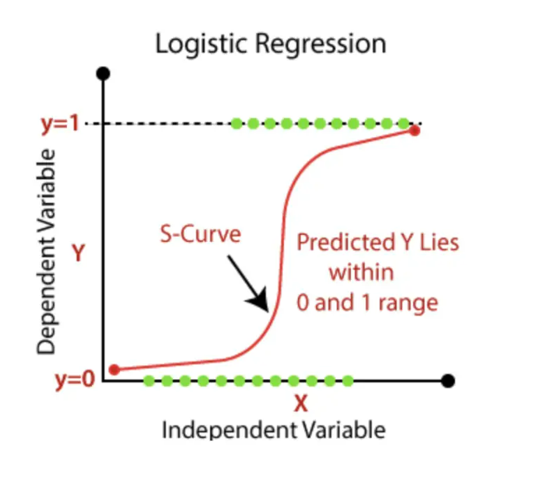
Figure 3. 1: Logistic regression explained with a graph.

3.1.2 Adaboost with Decision trees
AdaBoost is a type of ensemble learning method that combines multiple weak learners to create a stronger predictor. AdaBoost uses decision trees as its base classifiers to improve classification accuracy (Huang et al., 2022). The general idea behind AdaBoost is to sequentially train a series of decision trees, with each subsequent tree attempting to correct the mistakes of the previous tree. During each training iteration, the algorithm assigns a higher weight to misclassified samples from the previous iteration and lower weight to correctly classified samples. This process results in a new model that is better at classifying the previously misclassified samples.
AdaBoost can be a useful tool for improving the performance of machine learning models, particularly in the case of imbalanced datasets. However, AdaBoost is sensitive to noise and outliers in the training data, which can affect its performance (Li et al., 2019).

3.1.3 Random Forest
Random Forest is a decision tree-based ensemble learning algorithm used in classification and regression tasks. It creates multiple decision trees based on a random subset of features and then combines the results of each tree to make a final prediction. In the context of this project on credit card customer churn, Random Forest can be useful for predicting churn and identifying the most important factors that contribute to churn. It is a powerful algorithm that can handle large datasets with many features (Lalwani et al., 2021). It can also be used to address overfitting, a common problem in decision trees. It is also able to handle missing data and outliers, making it a flexible algorithm.
In this project, Random Forest is being considered as a useful machine learning algorithm, and its performance will be compared to other algorithms such as logistic regression and neural networks. This comparison will help to determine the most effective algorithm for achieving the project's objectives.
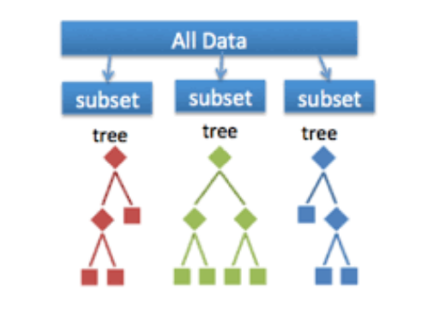
Figure 3. 2: Random Forest Algorithm.

3.1.4 Support Vector machines
Support Vector Machines (SVMs) are a common machine learning method that is used for classification and regression analysis. SVMs seek an ideal hyperplane in a high-dimensional feature space that can distinguish distinct classes of data points (Behravan et al., 2016). The hyperplane is chosen to maximise the margin, which is the distance between the hyperplane and the nearest data points in each class.
Support Vector Machines may be trained to identify consumers as churners or non-churners using churn-related data such as customer age, income, and education level. SVMs are very successful when the number of features is large, and the data points cannot be separated linearly. In machine learning, SVM models use kernel functions to transform input data into higher-dimensional spaces where the data points can be separated more easily. This technique is often employed to improve the model's predictive accuracy in certain situations. (Savas & Dovis, 2019).
SVMs outperform other classification algorithms in various ways. They are resistant to outliers and, by applying kernel functions, can handle non-linearly separable data. However, when working with huge datasets, SVMs may be computationally costly, and they require careful adjustment of hyperparameters to obtain optimal performance. SVMs can be sensitive to the kernel function used and may overfit if the model is too complicated.

3.1.5 Artificial Neutral Networks (ANNs)
Artificial Neural Networks (ANNs) are a form of machine learning algorithm that is modelled after the structure and function of the human brain. ANNs are made up of layers of linked nodes called neurons that analyse and send data (Montesinos López et al., 2022). The data is received by the input layer, and the results of the algorithm are produced by the output layer. The intermediate levels, known as hidden layers, oversee processing incoming data and producing output.
ANNs have been employed in a variety of data analytic applications, including customer churn prediction (SEYMEN et al., 2022). In this case, ANNs may be trained using a collection of historical customer data to find patterns that suggest whether a customer is likely to churn. Based on new input data, the trained ANN model may subsequently be utilised to forecast customer attrition.
Artificial neural networks (ANNs) are efficient in identifying intricate relationships between input and output data, which makes them an influential technique for predicting customer churn. However, they may consume a lot of computational resources and demand large amounts of data to train adequately (Wang et al., 2020). Sometimes, models can be too complicated and start to copy irrelevant details from the training data, causing problems when they're used with new data. This is called overfitting. That's why it's important to choose the right model and adjust its settings carefully when we're using ANNs to guess which customers might stop using a service.
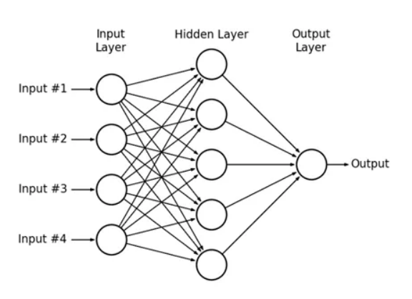
Figure 3. 3: Illustration of ANN’s process
This research will be based on a quantitative approach as the study is inductive in form and the focus of this thesis is on addressing a research gap with the purpose of solving a problem in a specific context. It will encompass research phases from data extraction through model implementation. Quantitative research is an investigation into a known issue that is built around testing a theory, quantified using data, and statistically assessed. Quantitative approaches seek to ascertain the validity of a theory's prediction generalisation. It can also be described as a technique for learning about a specific group of people known as a sample population, employs scientific inquiry and depends on data that is seen or measured to investigate questions about the sample population.
The findings of quantitative research provide an explanation for what is and is not significant to, or influences, a certain group. Quantitative research can also answer questions regarding the frequency of a phenomena or the magnitude with which it impacts the sample (Allen, 2017).
In this writeup, research questions have been formed based on desired outcomes and literature review. A broad overview of the literature review has also been given and then narrowed down to get a good understanding of the gaps identified and focused on.
Based on the literature review, the methodology would involve using suitable ML-methods for further studies, and their predictive performances compared to get the best results. The results will then be analysed and reported, and recommendations given from the predictive analysis done.

3.2 Data Collection
For the research on customer churn, a dataset containing customer data must be obtained, including demographic information, transaction history, and other relevant attributes for the aim of analysing and predicting customer attrition.
To ensure the legitimacy and validity of the data utilised for the project analysis, data was acquired from a credible and publicly available source to; the dataset used in this study is the Bank Churners dataset, which is publicly available on Kaggle. The dataset contains a representative sample of consumers, allowing findings to be generalised to the whole credit card customer base. The data collecting method was carried out with the goal of ensuring that the data is trustworthy, valid, and representative of the population of interest. The collection contains 10,000 anonymized customer records that include demographic and credit card use data.
The dataset contains columns which represent socioeconomic factors such as 'income' and 'education,' which are crucial to the study. It will be utilised in the prediction model to determine how these factors influence churn. The Bank Churners dataset will be used to investigate socioeconomic factors that influence credit card customer churn.

3.3 Data Pre-processing
Data pre-processing is a critical step in preparing the "bank churners" dataset for machine learning research. It ensures that the dataset is in the proper format and quality to be utilised for analysis, that the analysis is accurate and reliable, and that the results are understandable and actionable. In the instance of the "bank churners" dataset, data pre-processing will include the following steps:
Data Cleaning: This stage involves eliminating or repairing any mistakes, inconsistencies, or missing values from the dataset (Kumar & Khosla, 2018). For example, columns in the dataset with inconsistent values include "Education Level" and "Income Category."
Data transformation: This entails turning the data in some columns into a format that can be analysed. The main goal of data transformation is to make information more accessible, usable, and processable for people and systems. (Pandey et al., 2023). For example, the "Attrition Flag" column has two categories: "Existing Customer" and "Attrited Customer." This category may need to be converted from string to integer format, with "1" indicating "Attrited Customer" and "0" representing "Existing Customer" for easier analysis.
Data normalisation: In this step, the dataset columns will be normalised such that all columns have a similar range and some columns do not control the analysis because of their bigger values. Normalizing will guarantee that all columns are given equal weight in the analysis (Singh & Singh, 2021).
Feature selection: Like the data cleaning portion, the feature selection section will include a further reduction of the dataset by deleting irrelevant columns, leaving only columns important for the study. This can reduce clutter in the dataset and enhance analysis accuracy (Hanif & Azhar, 2017). Columns such as "clientnum" may be irrelevant to the analysis and can be removed.
Additional data pre-processing processes, such as description, head, tail, shape, and so on, will aid in providing an in-depth overview of the dataset as the analysis is performed.

3.4 Exploratory Data Analysis
Descriptive statistics and visualizations will be used to explore the relationships between the variables and identify any patterns or trends in the data. Each process of data analysis, including machine learning, must start with exploratory data analysis (EDA) (Lee & Lee, 2022). The data must be examined and visualised to be fully understood, including its distribution, correlation, and any possible outliers or mistakes. The dataset will be applied to EDA to better understand the variables that affect customer turnover and how they fluctuate among socioeconomic situations. With the use of this data, more potent methods may be created to improve client retention.
Some of the methods used to aid in the analysis and explanation of the dataset, its attributes, significant columns, and variables to offer a prognosis and remedy to the problem highlighted by the project include:
Descriptive statistics: Calculating summary statistics like mean, median, and standard deviation helps us understand the distribution and central tendency of the data using descriptive statistics.
Data visualisation: To show the data and spot patterns and trends, data visualisation will be done using various charts and graphs including histograms, scatter plots, and box plots.
Correlation analysis: This involves calculating the correlation between different columns in the dataset to identify the strength and direction of their relationship.
Outlier identification: Using boxplots and other tools, outlier detection can identify any extreme values or odd patterns in the data that may need additional investigation.

3.5 Model Training and Evaluation
The next phase is to train and assess machine learning models for prediction after conducting data pre-processing and feature selection. The dataset must first be divided into training and test sets. The models will be trained using the training set, and its performance will be assessed using the testing set. It is crucial that the training and testing sets are representative of the entire dataset, which implies that there should be a similar ratio of churners and non-churners in both sets. The models will be checked to see how accurate they are, using metrics such as precision, recall, and F1 score. These measurements help figure out how well the model is working and where changes would need to be made to make it better.

3.6 Interpretation of Results
The results will be interpreted to identify the key factors that contribute to customer churn.
Overall, this methodology aims to provide a comprehensive analysis of credit card customer churn, churn variance when socioeconomic factors such as income, education, gender etc are factored into the equation using machine learning techniques. The result interpretation will be used by researchers to further identify gaps that remain unsolved for business improvements. Most importantly the analysis will be used as a yardstick to control churn by focusing on those identified factors that likely cause churn and creating targeted customer experiences to control the likelihood of churn in individuals identified to process a number of these churn predictors.

Chapter 4 - Implementation

Using the procedures provided in chapter three as a guide, this chapter describes how the experiment was carried out. It details each phase of the pre-processing of the data as well as the testing of the machine learning models. The specific assessment metrics for each supervised machine learning model are also covered in this chapter. This phase of the analysis focuses on data gathering, data exploration, and data quality verification to get insight from the data and produce a hypothesis. The dataset utilised is the Bank Churners dataset, which is freely available on Kaggle. The dataset provides a representative sample of customers, allowing findings to be generalised to the whole credit card user population. The data collection procedure was carried out with the purpose of ensuring that the data is reliable, valid, and representative of the population of interest. The collection comprises 10,000 anonymized customer records that include demographic and credit card use information. The data was statistically and visually analysed using Python.

4.1 Dataset: Bank Churners
The Bank Churners dataset on Kaggle is a collection of data related to customers of a credit card company. The dataset contains 10,000 records and 23 columns.
The dataset contains information on customer demographics, usage patterns, and account history, as well as whether the customer churned or cancelled their credit card within the last six months. The dependent variable ‘Attrition Flag’ which is a Boolean variable that denotes whether a customer/member was retained or churned will be converted to integer format, with "1" indicating "Attrited Customer" and "0" representing "Existing Customer" for easier analysis.

4.2 Data Understanding
This chapter outlines the procedures used for the machine learning approaches in this study. This phase begins with data gathering, data exploration, quality assurance, and getting insight from the data to develop a hypothesis.
The dataset is loaded and the essential libraries for the analysis and prediction are installed via google collab.
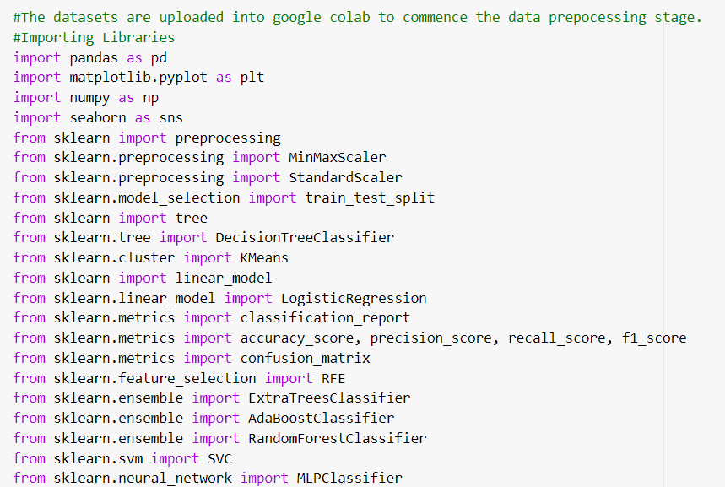
Figure 4. 1: Essential libraries required for the study’s analysis and prediction.

4.2 Data Cleaning
To get a detailed view and understanding of the bank churners dataset, a series of basic functionalities are applied on the dataset such as the. head (). tail (). shape, .info (). describe ().
The head and tail commands return the first and last 5 rows of the dataset, ‘. shape’ returns a tuple representing the dimensions of the dataset where the first number in the tuple represents the number of rows and the second number in the tuple represents the number of columns, ‘.info’ gives a full summary of the dataset, especially stating the non-null count and dtype. This function gives an easy view of any variable within the dataset having a null value and tells the data type of each column. The ‘, describe ()’ function calculates the statistical metrics of the table, which is used to tell the mean, min, max, standard deviation, and other similar metrics used to better understand the dataset. The inspection of the bank churner dataset shows that there are no missing values. The table below: Table 4.1, shows the dataset’s statistical metrics.
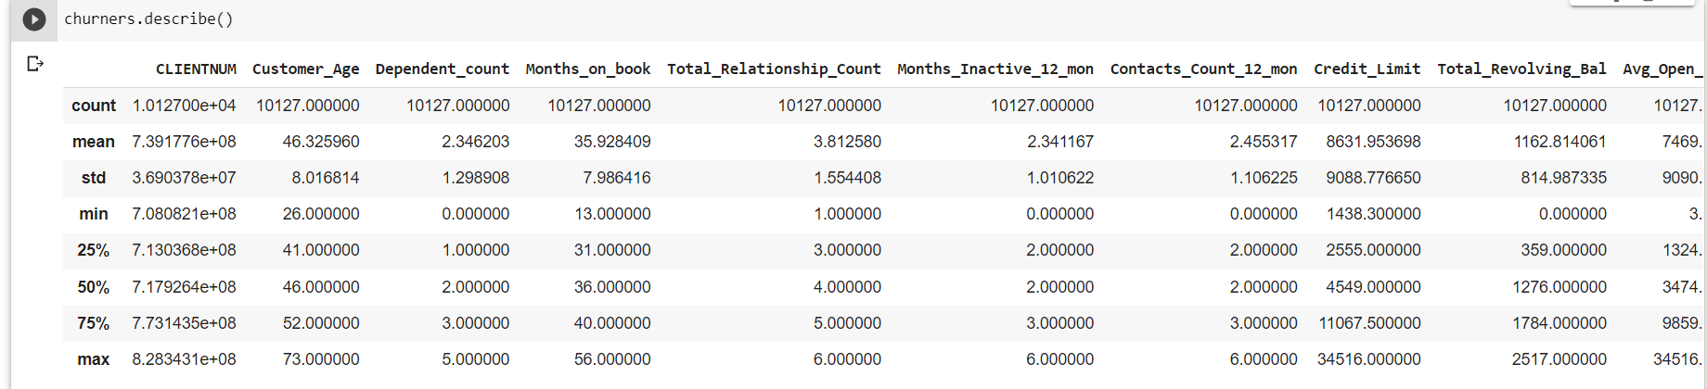
Table 4. 1: Statistical metrics of the Bank churners dataset

4.3 Data Transformation
The process of changing the form or structure of the data to make it more suitable for analysis or modeling. This can include techniques such as normalization, scaling, and standardization. For example, normalization can be used to scale all the values in a feature to a similar range, which can help certain models perform better. Columns such as “Attrition flag”, "Education Level", “Marital _status” , “Customer_age ”and "Income Category" needs to be scaled to ensure columns such as ‘age’ does not overshadow the analysis.

4.4 Data Encoding
Data encoding is the technique of converting categorical information into numerical variables, which is widely used to handle nominal and ordinal data effectively (Aich et al., 2019). Using the map function, a dictionary was created to map categorical values to numerical codes for each of the selected columns, replacing the categorical values with their corresponding numerical value. To view the newly adjusted columns, the ‘. head ()' function was used and table 4.2 below displays the five 5 rows of each column.
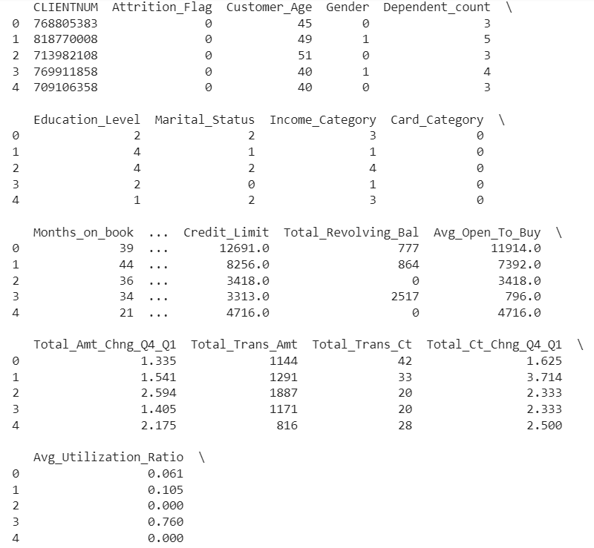
Table 4. 2: Table showing the newly converted numerical columns.

4.5 Feature selection
Feature selection is a method used in machine learning and data science to choose a subset of relevant predictors or variables for model development. Its primary goal is to simplify the model by removing redundant or insignificant information, which can improve the training process of machine learning algorithms (Sarker, 2021). The primary aim of feature selection is to enhance the performance of the model by improving its predictive accuracy, making faster and more precise predictions, and gaining a deeper understanding of the underlying predictive process (Linardatos et al., 2020). Feature selection techniques can be broadly classified into two categories: supervised and unsupervised. Supervised methods can be further categorized into wrapper, filter, and intrinsic approaches. The primary difference between these techniques is whether the features are selected based on the target variable. (Brownlee, 2020). The unsupervised feature selection technique, which is being used for this project, disregards the target variable, as opposed to techniques that remove redundant variables using correlation, and instead picks variables depending on the study subject and emphasis (Kassambara, 2017).
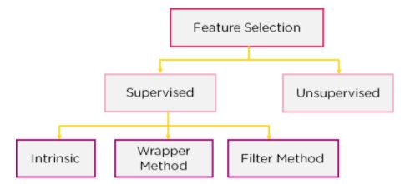
Figure 4. 2: Overview of Feature Selection Techniques

Selecting the right set of features is critical in ensuring that the model is robust and reliable. Adding irrelevant variables not related to the focus of discussion can cause complexity and result in overfitting, which leads to poor performance on new data. Conversely, leaving out important variables can lead to lower predictive accuracy and weaker insights into the underlying relationships between the variables. Therefore, it is crucial to carefully evaluate and select the most relevant features for the model to ensure its optimal performance. Ultimately, the goal is to strike a balance between the complexity of the model and its ability to accurately predict outcomes (OECD, 2021). The objective of this study was to understand the cause for churn across several factors – socio economical, educational, income wise etc in addition to age bracket. To this end, feature selection will be based on variables in the dataset of significance to the project topic.
Variables in the Bank churners dataset that are directly linked to the research question are ‘Customer Age’, ‘Gender’, ‘Education Level’, ‘Marital Status’, ‘Income Category’.
These variables will be selected, and others dropped as the research is based on identifying the extent of churn when all the above-mentioned factors are put into play as opposed to identifying variables with high relation and correlation to the dependent variable ‘Attrition flag’. Table 4.3 displays the new dataset showing the variables focused on in this study.
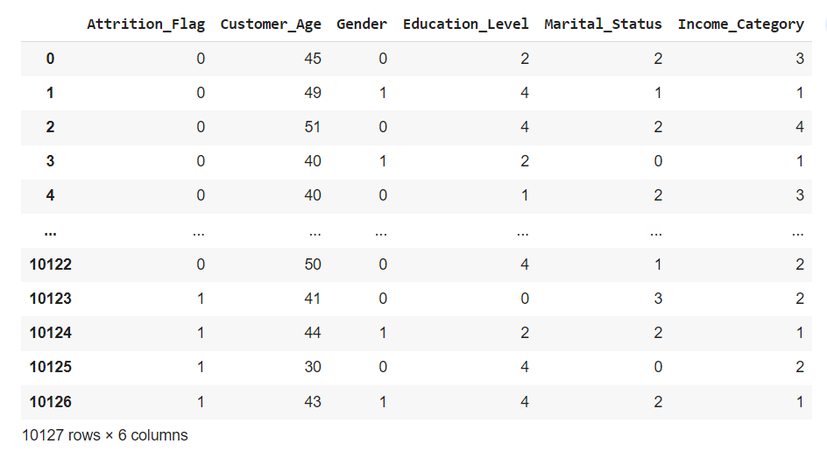
Table 4. 3: Selected variables from the Bank churners dataset for predictive analysis

4.6 Splitting the Dataset
In machine learning, the concept is to make models that can predict things accurately when new information is given. To make sure the model works well, it is trained on some data and then tested on a different data to see how it performs. (Badillo et al., 2020). This is where training and testing datasets come in.
A training dataset can be defined as a portion of the overall dataset that is utilized to teach a model. In essence, it is the information that is utilized by the model to comprehend the patterns and correlations that exist between the input variables and the output variables (Nichols et al., 2018). The aim is to produce a model that can perform well on novel and unseen data through the application of the acquired knowledge from the training dataset.
In machine learning, the testing dataset is a set of data that is separate from the training data, and it's used to check how well a model is doing. This means the model is tested with the testing dataset, and then compare the guesses with the actual answers to see how accurate it is. It's important that the testing dataset is a good sample of the real data that the model will eventually be used on. The reason the dataset is split into training and testing data is so that we can measure how well the model works with new data that it hasn't seen before. (Nguyen et al., 2021). This prevents overfitting, which occurs when a model performs well on training data but badly on testing data. When a model overfits, it learns the noise in the training data rather than the underlying patterns and correlations.
The most common way to split the dataset into training and testing datasets is to use the train_test_split function from the scikit-learn library. This function randomly splits the dataset into two subsets: one for training and one for testing. The size of the subsets can be specified as a percentage of the original dataset.
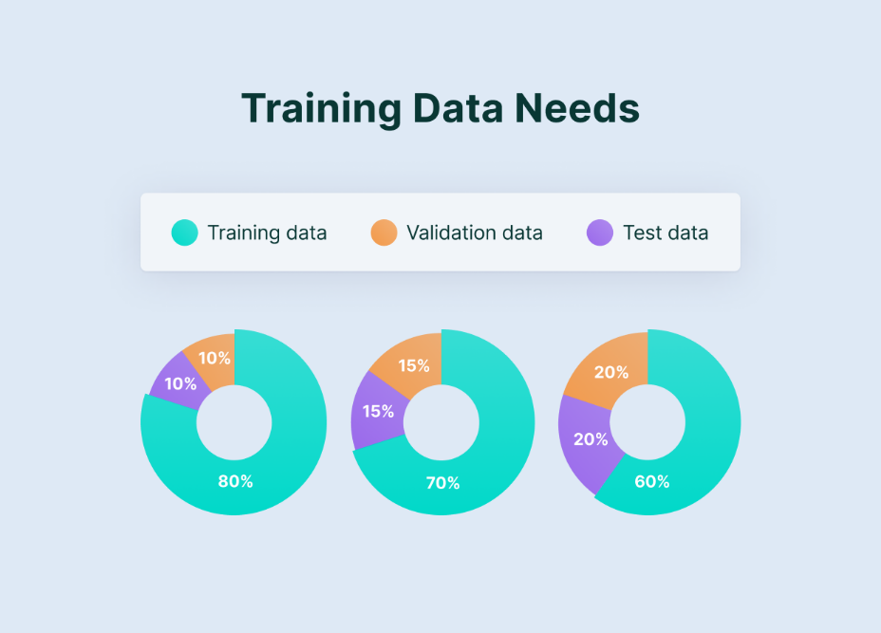
Figure 4. 3: Train, validate, test.

In machine learning, it's sometimes necessary to divide the training dataset into smaller subsets for validation and testing. As shown in Figure 4.28, the validation dataset is used to adjust the model's hyperparameters, which are settings that are set before training and not learned during training. Then, the testing dataset is used to measure the model's performance once it's fully trained. It's worth noting that this process helps to optimize the model's accuracy and effectiveness.
Overall, splitting the dataset into training and testing subsets is a critical step in the machine learning process, as it allows us to measure the performance of our model on new and unseen data and avoid overfitting.
I'll use train_test_split from sklearn to split the bank churners data.
train_test_split randomly divides the data into training and testing sets based on the ratio specified.
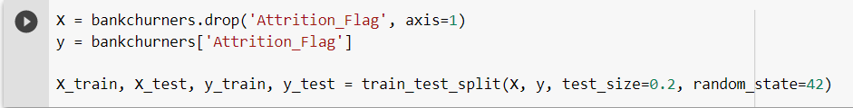

4.7 Model Training
The next step here is to train and evaluate various machine learning models for predicting customer churn and understanding credit card customer churn across age groups, amongst other factors. Various models will be employed, including logistic regression, decision trees, random forests, and neural networks.
To evaluate the performance of these models, metrics such as accuracy, precision, recall, and F1 score will be used.
Precision refers to the accuracy of positive predictions made by a model, measured as a percentage. Meanwhile, recall measures the ability of a model to identify positive samples from a dataset, also expressed as a fraction. To better comprehend these metrics, a confusion matrix can be employed as a visualization tool. (Kundu, 2022).
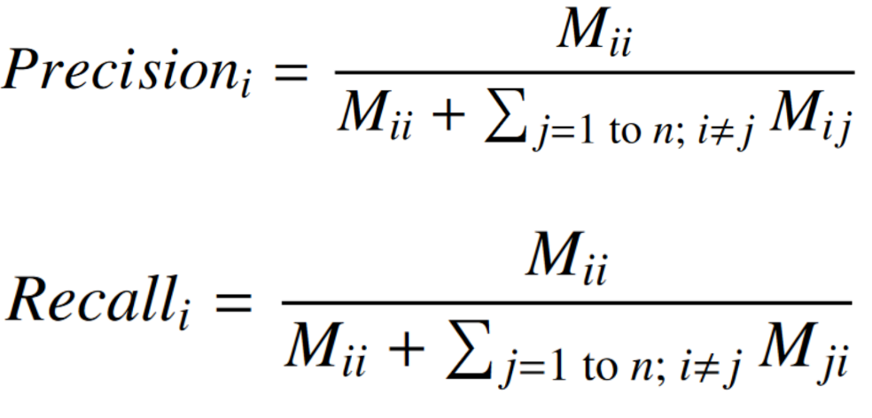
In machine learning, the F1 score is a metric used to evaluate a model's precision. It considers both the accuracy and recall scores of the model. The F-measure, also known as the F1 score, is often used to assess the performance of classification algorithms (Hand et al., 2021).
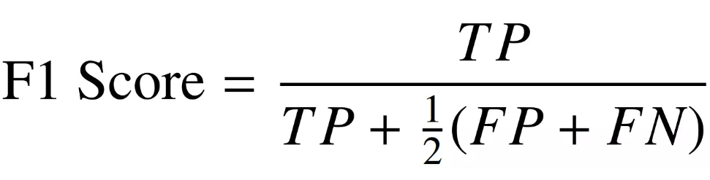
In this analysis, precision measures the proportion of true churners among those predicted as churners, recall measures the proportion of true churners correctly identified by the model, and F1 score is the harmonic mean of precision and recall. By analysing these metrics, I will be able to determine how well the models are performing and identify areas where they need improvement. The model that performs the best on these measures will be chosen as the final model.
This approach will tell which factor(s) has the most influence on customer churn. Ultimately, the findings of this research can be used by credit card companies to develop more effective strategies for retaining their customers and improving the overall customer experience.
The selected machine learning models for predicting churn will now be tested individually to know which has the best churn prediction value. The method begins with fitting the model to training data and then assessing its performance on unseen test data. The model's accuracy is then calculated by comparing the actual values from the test data.
Other parameters, such as accuracy, recall, and F-measure, are also considered. Especially F-measure because class imbalance might result in high accuracy rating and precision but low recall.

4.7.1 Logistics Regression
The logistic regression code is a classification technique that predicts a binary result. To begin, the code selects columns from the dataset for training and testing. The assessment metrics begin as empty lists. The code then runs over each column chosen for logistic regression model training and testing. The data is split into training and testing sets for each iteration using the scikit-learn library's train_test_split () method.
The evaluation metrics, which include accuracy, precision, recall, and F1-score, are computed using functions from the scikit-learn library, and the results are appended to the respective lists. Finally, using pandas, a table containing the assessment results for each column is constructed and shown.
Python's 'from sklearn. linear_model import LogisticRegression' command was used to import the Logistic Regression model. The resulting prediction are as follows:
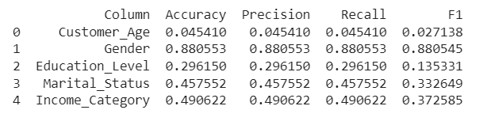
Table 4. 4: Tabular view of logistics regression model results

4.7.2 AdaBoost with Decision trees
Python's from sklearn. tree import DecisionTreeClassifier' and ‘from sklearn. ensemble import AdaBoostClassifier’ command was used to import the AdaBoost model, and the number of estimators is specified to be 50. The evaluation metrics are calculated using accuracy_score, precision_score, recall_score, and f1_score functions, with average parameter set to 'micro' for precision, and 'weighted' for recall and f1 score. The resulting prediction are as follows:
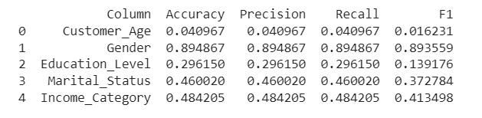
Table 4. 5: Tabular view of AdaBoost with Decision trees model results

4.7.3 Random Forest
To aid in the study, the estimator in RF has been raised to 100. The model will perform better because it will be able to learn more complicated associations in the data if there are 100 additional estimators, which will result in 100 decision trees. But as the number of estimators rises, so do the model's computational complexity and training time.
There is no assurance that adding more estimators would enhance performance noticeably; in fact, it may potentially result in overfitting. To prevent overfitting, it's crucial to carefully tweak the RandomForestClassifier model's hyperparameters and keep an eye on the model's performance.
Python's ‘from sklearn. ensemble import RandomForestClassifier’ command was used to import the RandomForest model. The resulting prediction are as follows:
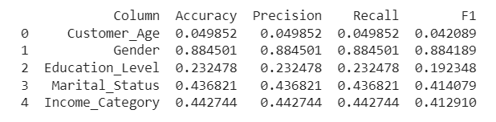
Table 4. 6: Tabular view of the random forest model results

4.7.4 Support vector machine
In machine learning, the SVM estimator has been configured to use a "linear" setting. A kernel parameter in SVM models is responsible for transforming the input data into a higher-dimensional space, where the data can be separated more easily. There are three common kernel functions used, which are polynomial, radial basis function (RBF), and linear.
When the data are already clearly segregated in the original feature space or there are a lot of features in comparison to the number of samples, using a linear kernel might be a wise decision. In these circumstances, using a more complicated kernel function, such a polynomial or RBF, may result in overfitting and poor generalisation performance.
Python's from sklearn import SVM command was used to import the Support Vector Machine model. The resulting prediction are as follows:
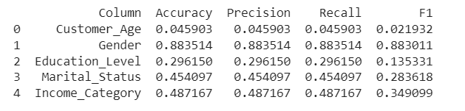
Table 4. 7: Tabular view of the SVM model results

4.7.5 Artificial Neutral network
ANN is a sort of machine learning algorithm that is inspired by the structure and function of the human brain and is trained through a process called Backpropagation. This is a method that modifies the weights of the connections between the nodes to minimise the difference between the expected and actual target variable.
Python's from ‘keras. models import Sequential’ and ‘from keras. layers import Dense command’ was used to import and run the ANN model. The resulting prediction are as follows:
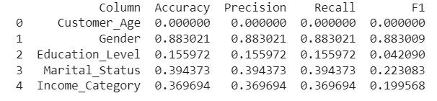
Table 4. 8: ANN model and metrics results

The algorithm used on all models divides the dataset into training and testing sets to evaluate the model's performance on fresh, previously unknown data. The model's performance is measured using accuracy, precision, recall, and the F1 score. The algorithm analyses the model's effectiveness in predicting each individual characteristic independently by looping over each column as the goal variable. This enables for a more complete examination of the model's accuracy and generalizability to fresh data.
The table below shows the models trained on the bank churner dataset and the level of accuracy of each model on separate columns. The results and findings would be discussed in the next chapter.

Table 4. 9: Accuracy results of the trained model

Chapter 5 - Results and Discussion

5.1 Discussion
This chapter discusses the analyses and outcomes obtained from several machine learning models investigated for categorization problems. Beginning with logistic regression, which predicts a binary target variable based on a collection of characteristics and progressing to ensemble models like AdaBoost and Random Forest, which employ numerous decision trees to produce more accurate predictions. Support Vector Machines were also exhibited as a model that separates classes in the feature space using a hyperplane. Finally, Artificial Neural Networks were investigated, which are a collection of interconnected nodes that collaborate to forecast the goal variable. The dataset was divided into training and testing sets for each model to evaluate the model's performance using measures such as accuracy, precision, recall, and F1 score. The results from all tested models are pasted below.

Table 5. 1: Results from tested models and metrics

5.2 Metrics Analysis
The entire analysis was run on google collab, using the panda’s libraries. The models applied produced different results. However, across the metrics applied on each model, results were similar, in some cases, the same.
For logistic regression, we used the selected metrics to visualize the model's performance. The accuracy, precision, recall, and F1 score for the model were 0.52, 0.43, 0.43 and 0.35, respectively.
For decision trees, we used the selected metrics and calculated the accuracy, precision, recall, and F1 score for the model. The average accuracy, precision, recall, and F1 score were 0.44, 0.44, 0.44 and 0.37, respectively.
For random forests, we used the selected metrics and calculated the accuracy, precision, recall, and F1 score for the model. The accuracy, precision, recall, and F1 score were 0.41, 0.41, 0.41 and 0.39, respectively. Across all the models, the metrics gave similar scores except F1 and Random Forest model had the highest average F1 score of 0.389, performing best overall across all columns.
For neural networks, we used the selected metrics and calculated the accuracy, precision, recall, and F1 score for the model. The accuracy, precision, recall, and F1 score were 0.36, 0.36, 0.36 and 0.30, respectively.
Overall, Random Forest performed the best, followed by Adaboost and ANN. Logistic Regression and SVM had the lowest scores. Therefore, based on these scores, we can say that Random Forest is the best model for this dataset.
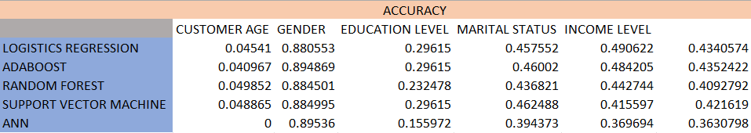
ACCURACY

Table 5. 2: Tabular view of accuracy metrics results for each model.

Figure 5. 1: Accuracy metrics on tested models
In figure 5.1 above, the results of random forest across all the variables were higher than all other models applied. To verify the consistency of the random forest model in predicting the best results, other metrics such as precision, recall and F1 were tested results pasted in figure 5.2, 5.3, and 5.4 below, producing consistent results to further affirm the selection of the random forest model as the best model for predicting customer churn, where socioeconomic factors such as age, gender, education – typical factors common to every customer of any organisation, is taken into consideration. This gives a clear answer to one of the research questions.

PRECISION
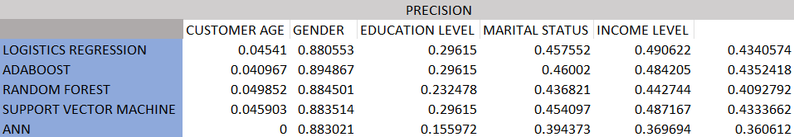
Table 5. 3: Tabular view of precision metrics results for each model.

Figure 5. 2: Precision result on test models

RECALL
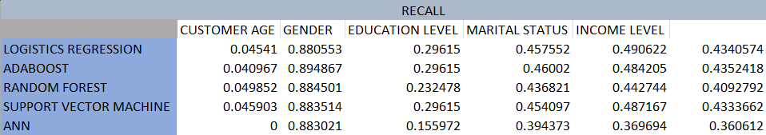
Table 5. 4: Tabular view of recall metrics results for each model.

Figure 5. 3: Recall result on test models

F1 SCORE
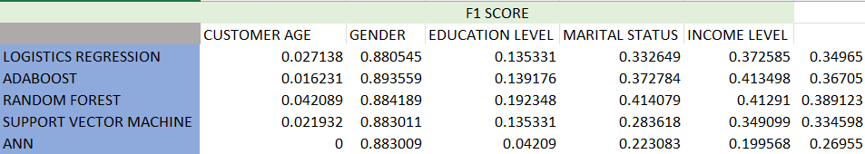
Table 5. 5: Tabular view of F1 metrics results for each model.

Figure 5. 4: F1 result on test models.
To answer the second part of the research question in this study - What socio-economic factor has the most likely influence on customer churn? Feature selection is run on the Random Forest model. The predictor with the largest magnitude of coefficient (positive or negative) can be considered the most influential socio-economic factor in predicting customer churn.
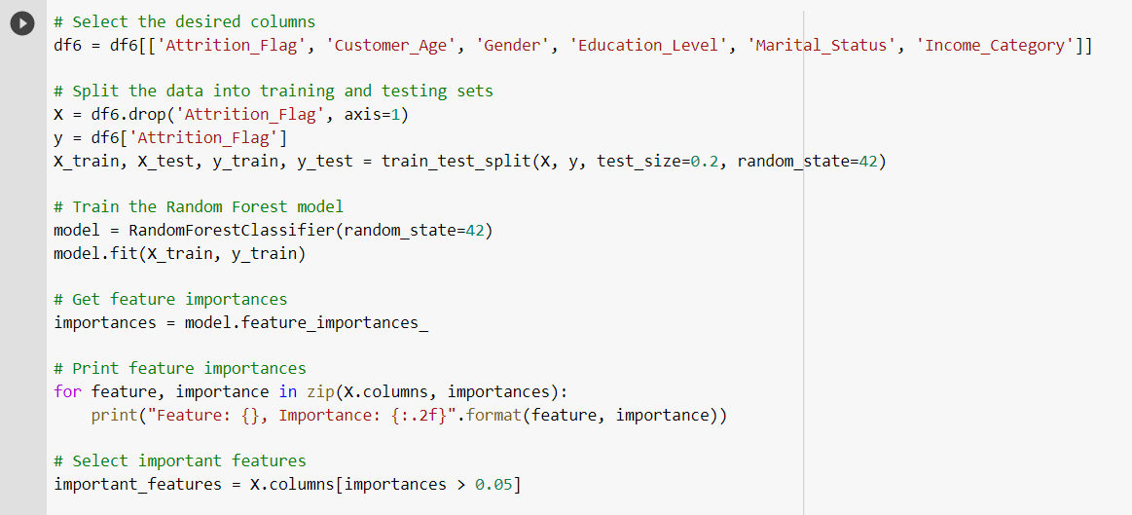
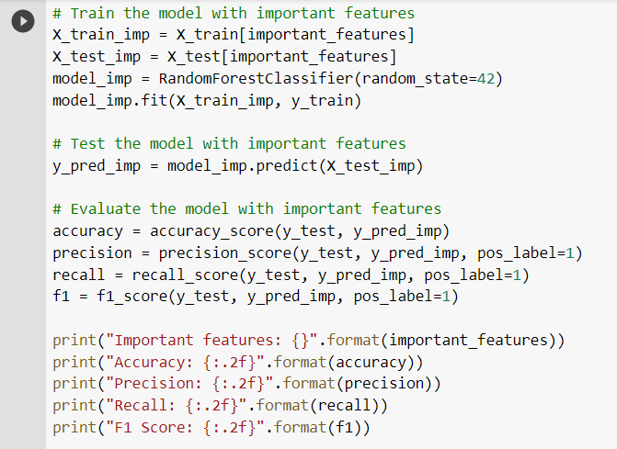
Figure 5. 5: Feature selection for highest attrition factor
First, the desired columns are selected from the dataset. Then the dataset divided into two parts - one for training the model, and the other to test how well it works. The important parts of the data that will help the model make the best predictions is selected. Then the random forest model is then trained and evaluated to determine the most important feature affecting customer churn in the present dataset. Finally, the accuracy, precision, recall, and F1 score of the model are tested to validate the result.
The result:
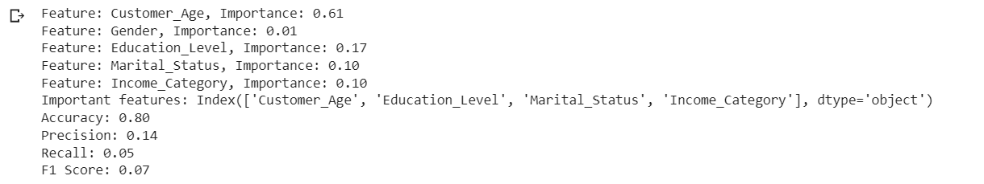
Figure 5. 6: Feature selection result for highest Attrition factor
Figure 5.6 above shows that the variable ‘Age’ is the highest factor that determines customer churn or attrition. The Bank churner dataset shows that there is a total of 10,127 customers with customer age ranging from Age 26 - 73. The graph below shows that majority of the customers are within the age bracket of 41 -51.
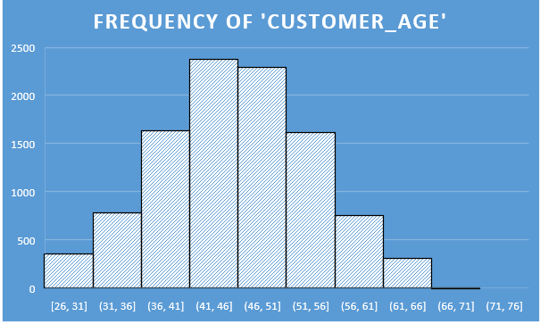
Figure 5. 7: Age range of customers in the Bankchurners dataset.

The analysis and results show that the credit card company has a higher number of customers within the age bracket of 40 -50 with the age bracket retaining the highest number of churners.
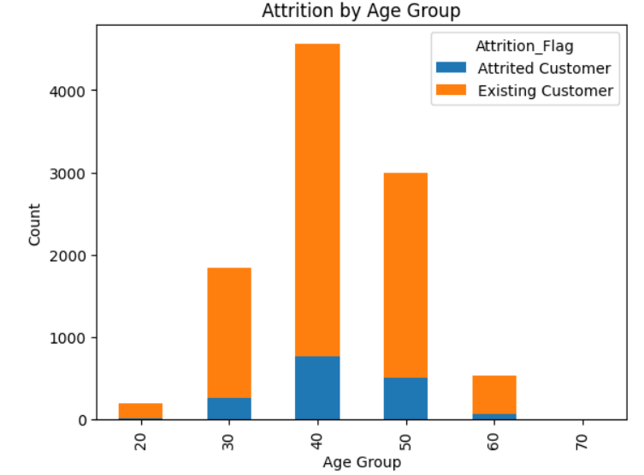
Figure 5. 8: Distribution of Attrited and Existing customer across Age brackets.
Using the analysis done on the bankchurners dataset, credit card companies are advised to focus on the age bracket with the highest number of churners, understand their peculiarities, likes and lifestyle and create targeted customer experience journey maps for this identified age group to retain their interest, patronage and ultimately reduce the churn rate within this age group.
For predicting potential customer churn in the future, any of the models developed in this research - such as Logistic Regression, Random Forest, SVM, or ANN - can be utilized. To make predictions on the new data, it needs to be pre-processed using the same techniques applied to the training data during the study. Once the pre-processing is complete, the trained model can be employed to generate forecasts on the new data.
After the predictions have been made, the churn rate can be calculated by dividing the number of customers predicted to churn by the total number of customers in the future data. This will give an estimate of the future churn rate for the organisation, give an insight into the number of customers they are at risk of losing, the number of socio-economic factors each of the customer identify with, the factor that affects churn the most, and use all gathered information to reduce churn, create targeted customer experience journey maps to keep them happy and loyal advocates of the company.

Chapter 6 - Conclusion

6.1 Conclusion and reflection
This project demonstrates the importance of understanding the socioeconomic factors that drive customer churn in the credit card industry. The life force of every business is the customers, and it is the duty of companies to understand each customer’s needs in line with their personal attributes to provide targeted experiences. These identified socio-economic factors are very important and to a large extent, determine the customer’s relation with the credit card industry as it the focus of this research. For instance, if a customer’s income category drops, there is a likelihood that there will be a positive correlation in the customer’s spending habit. Similar comparison cuts across all examined socio-economic factors in this research.
The use of machine learning models such as Random forest can help identify these factors and aid in developing strategies to reduce customer churn. The study also highlights the need for companies to personalize their services and understand each customer's unique experience to increase customer lifetime value as it is recognised that it is cost effective to channel resources to retain already existing customers than attract potential customers.

6.2 Future work
There are several areas that could be explored as a future work related to customer churn in the credit card industry. For one, this analysis could be extended to include more socio-economic factors beyond age, gender, education level, marital status, and income category. For instance, factors such as employment status, geographical location, and spending behaviour could also be considered.
Other potential factors that may contribute to churn that were not considered in this analysis as they are not commonly attributed to every individual and must do more with the company’s interaction with the customer are factors such as customer service, rewards programs, and marketing strategies. Future studies could investigate the interplay between these factors and socio-economic factors to identify the most effective strategies for retaining customers.
It would be interesting to replicate this analysis across other industries to determine if similar socio-economic factors are important in predicting customer churn. For instance, if the same factors that contribute to customer churn in credit card companies also contribute to churn in the telecommunications or retail industries.
There are numerous avenues for future research in this area, and a deeper understanding of the factors that influence customer churn in the credit card industry could have significant implications for business strategy and customer retention efforts. By understanding these factors and their interplay with other potential factors, companies can make more informed decisions regarding customer retention strategies and personalized customer experience journeys.

References
Adke, V., Bakhshi, P. and Askari, M. (2022) “Impact of disruptive technologies on Customer Experience Management in ASEAN: A Review,” 2022 IEEE International Conference on Computing (ICOCO) [Preprint]. Available at: https://doi.org/10.1109/icoco56118.2022.10031882.
Aich, A. et al. (2019) “Encoding web-based data for efficient storage in machine learning applications,” 2019 Fifteenth International Conference on Information Processing (ICINPRO) [Preprint]. Available at: https://doi.org/10.1109/icinpro47689.2019.9092264
Alhaqui, F., Elkhechafi, M. and Elkhadimi, A. (2022) “Machine Learning for Telecoms: From churn prediction to Customer Relationship Management,” 2022 IEEE International Conference on Machine Learning and Applied Network Technologies (ICMLANT) [Preprint]. Available at: https://doi.org/10.1109/icmlant56191.2022.9996496.
Al Hakim, Z.T., Sengupta, S. and Cuny, C. (2020) “Impact of shared history on customers’ service evaluations,” Journal of Retailing and Consumer Services, 55, p. 102070. Available at: https://doi.org/10.1016/j.jretconser.2020.102070.
Allen, M. (2017) “The sage encyclopedia of communication research methods,” Quantitative Research, Steps for [Preprint]. Available at: https://doi.org/10.4135/9781483381411.
Allen, M. Patrick (1997) “The problem of multicollinearity,” Understanding Regression Analysis, pp. 176–180. Available at: https://doi.org/10.1007/978-0-585-25657-3_37.
AlZoman, R.M. and Alenazi, M.J. (2021) “A comparative study of traffic classification techniques for Smart City Networks,” Sensors, 21(14), p. 4677. Available at: https://doi.org/10.3390/s21144677.
Asniar and Surendro, K. (2019) “Predictive analytics for predicting customer behaviour,” 2019 International Conference of Artificial Intelligence and Information Technology (ICAIIT) [Preprint]. Available at: https://doi.org/10.1109/icaiit.2019.8834571
.
Badillo, S. et al. (2020) “An introduction to machine learning,” Clinical Pharmacology & Therapeutics, 107(4), pp. 871–885. Available at: https://doi.org/10.1002/cpt.1796.
Bashar, A. et al. (2022) “Excelling customer experience through data driven Behavioral Intelligence: A conceptual framework,” 2022 International Conference on Data Analytics for Business and Industry (ICDABI) [Preprint]. Available at: https://doi.org/10.1109/icdabi56818.2022.10041675.
Batat, W. (2022) “Strategies for the digital customer experience.” Available at: https://doi.org/10.4337/9781800371897.
Behare, N., Waghulkar, S. and Shah, S.A. (2018) “A theoretical perspective on customer experience (CX) in Digital Business Strategy,” 2018 International Conference on Research in Intelligent and Computing in Engineering (RICE) [Preprint]. Available at: https://doi.org/10.1109/rice.2018.8509079.
Behravan, I. et al. (2016) “An optimal SVM with feature selection using multiobjective PSO,” Journal of Optimization, 2016, pp. 1–8. Available at: https://doi.org/10.1155/2016/6305043.
Doan, Q.H. et al. (2022) “A cluster-based data splitting method for small sample and class imbalance problems in impact damage classification,” Applied Soft Computing, 120, p. 108628. Available at: https://doi.org/10.1016/j.asoc.2022.108628.
Dwivedi, Y.K. et al. (2021) “Setting the future of digital and social media marketing research: Perspectives and Research Propositions,” International Journal of Information Management, 59, p. 102168. Available at: https://doi.org/10.1016/j.ijinfomgt.2020.102168.
Ertuğrul, Ö.F. and Tağluk, M.E. (2017) “A novel version of k nearest neighbour: Dependent nearest neighbour,” Applied Soft Computing, 55, pp. 480–490. Available at: https://doi.org/10.1016/j.asoc.2017.02.020.
Hand, D.J., Christen, P. and Kirielle, N. (2021) “F*: An interpretable transformation of the F-measure,” Machine Learning, 110(3), pp. 451–456. Available at: https://doi.org/10.1007/s10994-021-05964-1.
Hanif, A. and Azhar, N. (2017) “Resolving class imbalance and feature selection in customer churn dataset,” 2017 International Conference on Frontiers of Information Technology (FIT) [Preprint]. Available at: https://doi.org/10.1109/fit.2017.00022.
Huang, X. et al. (2022) “Fair-AdaBoost: Extending AdaBoost method to achieve fair classification,” Expert Systems with Applications, 202, p. 117240. Available at: https://doi.org/10.1016/j.eswa.2022.117240.
Jangra, G. and Jangra, M. (2022) “Role of artificial intelligence in online shopping and its impact on consumer purchasing behaviour and decision,” 2022 Second International Conference on Computer Science, Engineering and Applications (ICCSEA) [Preprint]. Available at: https://doi.org/10.1109/iccsea54677.2022.9936374.
Jantti, M. and Hyvarinen, S. (2018) “Exploring Digital Transformation and digital culture in service organizations,” 2018 15th International Conference on Service Systems and Service Management (ICSSSM) [Preprint]. Available at: https://doi.org/10.1109/icsssm.2018.8465007.
Jeong Sang-hee and Byoung-Gyu Chung (2019) “Moderating effects of age groups on Digital Customer Experience and purchase,” Journal of Distribution and Management Research, 22(3), pp. 13–20. Available at: https://doi.org/10.17961/jdmr.22.3.201906.13.
Kao, C. (2010) “Fuzzy Data Standardization,” IEEE Transactions on Fuzzy Systems, 18(4), pp. 745–754. Available at: https://doi.org/10.1109/tfuzz.2010.2047948.
Kassambara, A. (2017) Practical guide to cluster analysis in R: Unsupervised machine learning. Erscheinungsort nicht ermittelbar: STHDA.
Kumar, V. and Khosla, C. (2018) “Data Cleaning-A thorough analysis and survey on unstructured data,” 2018 8th International Conference on Cloud Computing, Data Science & Engineering (Confluence) [Preprint]. Available at: https://doi.org/10.1109/confluence.2018.8442950.
Kwak, S.K. and Kim, J.H. (2017) “Statistical Data Preparation: Management of missing values and outliers,” Korean Journal of Anesthesiology, 70(4), p. 407. Available at: https://doi.org/10.4097/kjae.2017.70.4.407.
Lalwani, P. et al. (2021) “Customer churn prediction system: A machine learning approach,” Computing, 104(2), pp. 271–294. Available at: https://doi.org/10.1007/s00607-021-00908-y.
Lee, J. and Lee, I. (2022) “Exploratory data analysis of manufacturing data,” 2022 13th International Conference on Information and Communication Technology Convergence (ICTC) [Preprint]. Available at: https://doi.org/10.1109/ictc55196.2022.9952974.
Lemon, K.N. and Verhoef, P.C. (2016) “Understanding customer experience throughout the customer journey,” Journal of Marketing, 80(6), pp. 69–96. Available at: https://doi.org/10.1509/jm.15.0420.
Li, K. et al. (2019) “Improved PSO_AdaBoost Ensemble Algorithm for Imbalanced Data,” Sensors, 19(6), p. 1476. Available at: https://doi.org/10.3390/s19061476.
Linardatos, P., Papastefanopoulos, V. and Kotsiantis, S. (2020) “Explainable AI: A Review of Machine Learning Interpretability Methods,” Entropy, 23(1), p. 18. Available at: https://doi.org/10.3390/e23010018.
Malik, R., Jindal, T. and Sharma, A. (2022) “Role of artificial intelligence in reshaping retail,” 2022 2nd International Conference on Advance Computing and Innovative Technologies in Engineering (ICACITE) [Preprint]. Available at: https://doi.org/10.1109/icacite53722.2022.9823675.
Montesinos López, O.A., Montesinos López, A. and Crossa, J. (2022) “Fundamentals of Artificial Neural Networks and deep learning,” Multivariate Statistical Machine Learning Methods for Genomic Prediction, pp. 379–425. Available at: https://doi.org/10.1007/978-3-030-89010-0_10.
Mukaka M. M. (2012) Statistics corner: “A guide to appropriate use of correlation coefficient in medical research”. Malawi medical journal: the journal of Medical Association of Malawi, 24(3), 69–71.
Nalini, R. et al. (2018) “Digital payments- embellishing customer experience,” 2018 Internat2018 International Conference on Computation of Power, Energy, Information and Communication (ICCPEIC)zonal conference on computation of power, energy, Information and Communication (ICCPEIC) [Preprint]. Available at: https://doi.org/10.1109/iccpeic.2018.8525226.
Närvänen, E. et al. (2020) “A meaning-based framework for customer loyalty,” International Journal of Retail & Distribution Management, 48(8), pp. 825–843. Available at: https://doi.org/10.1108/ijrdm-05-2019-0153.
Nguyen, Q.H. et al. (2021) “Influence of data splitting on performance of machine learning models in prediction of shear strength of Soil,” Mathematical Problems in Engineering, 2021, pp. 1–15. Available at: https://doi.org/10.1155/2021/4832864.
Nichols, J.A., Herbert Chan, H.W. and Baker, M.A. (2018) “Machine learning: Applications of artificial intelligence to imaging and diagnosis,” Biophysical Reviews, 11(1), pp. 111–118. Available at: https://doi.org/10.1007/s12551-018-0449-9.
OECD (2021), Artificial Intelligence, Machine Learning and Big Data in Finance: Opportunities, Challenges, and Implications for Policy Makers, https://www.oecd.org/finance/artificial-intelligence-machine-learningbig-data-in-finance.htm
Pandey, S. et al. (2023) “Data Integration and transformation using artificial intelligence,” 2023 International Conference on Intelligent Data Communication Technologies and Internet of Things (IDCIoT) [Preprint]. Available at: https://doi.org/10.1109/idciot56793.2023.10053513.
Pieska, S., Luimula, M. and Suominen, T. (2016) “Generating wow experiences with small and medium-sized enterprises,” 2016 International Symposium on Small-scale Intelligent Manufacturing Systems (SIMS) [Preprint]. Available at: https://doi.org/10.1109/sims.2016.7802897.
Pine II, B.J. (2020) “Designing employee experiences to create customer experience value,” Strategy &amp; Leadership, 48(6), pp. 21–26. Available at: https://doi.org/10.1108/sl-08-2020-0114.
Sarker, I.H. (2021) “Machine learning: Algorithms, real-world applications and Research Directions,” SN Computer Science, 2(3). Available at: https://doi.org/10.1007/s42979-021-00592-x.
Savas, C. and Dovis, F. (2019) “The impact of different kernel functions on the performance of scintillation detection based on support Vector Machines,” Sensors, 19(23), p. 5219. Available at: https://doi.org/10.3390/s19235219.
SEYMEN, O.F. et al. (2022) “Customer churn prediction using ordinary artificial neural network and Convolutional Neural Network Algorithms: A comparative performance assessment,” GAZI UNIVERSITY JOURNAL OF SCIENCE [Preprint]. Available at: https://doi.org/10.35378/gujs.992738.
Singh, N. and Singh, P. (2021) “Exploring the effect of normalization on Medical Data Classification,” 2021 International Conference on Artificial Intelligence and Machine Vision (AIMV) [Preprint]. Available at: https://doi.org/10.1109/aimv53313.2021.9670938.
Subasi, A. (2020) “Machine learning techniques,” Practical Machine Learning for Data Analysis Using Python, pp. 91–202. Available at: https://doi.org/10.1016/b978-0-12-821379-7.00003-5.
Tasnim, A. et al. (2022) “Performance evaluation of multiple classifiers for predicting fake news,” Journal of Computer and Communications, 10(09), pp. 1–21. Available at: https://doi.org/10.4236/jcc.2022.109001.
Tamrakar, M.K. and Badholia, A. (2022) “Scientific study of technological chatbot adoption in Customer Service,” 2022 3rd International Conference on Electronics and Sustainable Communication Systems (ICESC) [Preprint]. Available at: https://doi.org/10.1109/icesc54411.2022.9885724.
Tyrväinen, O. and Karjaluoto, H. (2019) “Omnichannel Experience: Towards successful channel integration in retail,” Journal of Customer Behaviour, 18(1), pp. 17–34. Available at: https://doi.org/10.1362/147539219x15633616548498.
Uddin, S. et al. (2022) “Comparative performance analysis of K-nearest neighbour (KNN) algorithm and its different variants for disease prediction,” Scientific Reports, 12(1). Available at: https://doi.org/10.1038/s41598-022-10358-x.
van der Goot, M.J. and Pilgrim, T. (2020) “Exploring age differences in motivations for and acceptance of chatbot communication in a customer service context,” Chatbot Research and Design, pp. 173–186. Available at: https://doi.org/10.1007/978-3-030-39540-7_12.
Voorhees, C.M. et al. (2017) “Service encounters, experiences and the Customer Journey: Defining the field and a call to expand our lens,” Journal of Business Research, 79, pp. 269–280. Available at: https://doi.org/10.1016/j.jbusres.2017.04.014.
Zhao, Y. et al. (2021) “Research on the influence mechanism of Artificial Intelligence (AI) customer service on user satisfaction with online shopping,” 2021 2nd International Conference on Computer Science and Management Technology (ICCSMT) [Preprint]. Available at: https://doi.org/10.1109/iccsmt54525.2021.00056.
Zhyli (2020) Prediction of churning credit card customers, Zenodo. Available at: https://zenodo.org/record/4322342 (Accessed: March 20, 2023).

Bibliography
Brownlee, J. (2020) How to choose a feature selection method for machine learning, MachineLearningMastery.com. Available at: https://machinelearningmastery.com/feature-selection-with-real-and-categorical-data/ (Accessed: April 2023).
Carty, D. (2021) Training, validation and testing data explained, Applause. Available at: https://www.applause.com/blog/training-data-validation-data-vs-test-data (Accessed: April 2023).
Cheng Hua, D.Y.-J.C. (2021) Companion to BER 642: Advanced regression methods, book down. Available at: https://bookdown.org/chua/ber642_advanced_regression/ (Accessed: April 2023).
Forecast Global (2023) Feature engineering, Corporate Finance Institute. Edited by S. Taylor. Available at: https://corporatefinanceinstitute.com/resources/data-science/feature-engineering/ (Accessed: April 2023).
Gawali, S. (2023) Skewness and kurtosis: Quick guide (updated 2023), Analytics Vidhya. Available at: https://www.analyticsvidhya.com/blog/2021/05/shape-of-data-skewness-and-kurtosis/ (Accessed: April 2023).
Juba, B. and Le, H.S. (2019) “Precision-recall versus accuracy and the role of large data sets,” Proceedings of the AAAI Conference on Artificial Intelligence, 33(01), pp. 4039–4048. Available at: https://doi.org/10.1609/aaai.v33i01.33014039.
Kundu, R. (2022) Precision vs. recall: Differences, use cases & evaluation, V7. Available at: https://www.v7labs.com/blog/precision-vs-recall-guide (Accessed: April 2023).
Lindecrantz, E., Gi, M.T.P. and Zerbi, S. (2020) Personalizing the customer experience: Driving differentiation in retail, McKinsey & Company. McKinsey & Company. Available at: https://www.mckinsey.com/industries/retail/our-insights/personalizing-the-customer-experience-driving-differentiation-in-retail (Accessed: April 2023).
Liu, C. (2023) Data transformation: Standardization vs normalization, KDnuggets. Available at: https://www.kdnuggets.com/2020/04/data-transformation-standardization-normalization.html (Accessed: April 2023).
Mesevage, T.G. (2021) What is data pre-processing & what are the steps involved? Monkey Learn Blog. Available at: https://monkeylearn.com/blog/data-preprocessing/ (Accessed: April 2023).
Ranganathan, P., Pramesh, C. S., & Aggarwal, R. (2017). Common pitfalls in statistical analysis: Logistic regression. Perspectives in clinical research, 8(3), 148–151
Schwager, A. and Meyer, C. (2022) Understanding customer experience, Harvard Business Review. Available at: https://hbr.org/2007/02/understanding-customer-experience (Accessed: March 2023).
Srivastava, T. (2023) A complete guide to K-Nearest Neighbours (updated 2023), Analytics Vidhya. Available at: https://www.analyticsvidhya.com/blog/2018/03/introduction-k-neighbours-algorithm-clustering/ (Accessed: April 2023).
Xu, Y. and Goodacre, R. (2018) “On splitting training and validation set: A comparative study of cross-validation, bootstrap and systematic sampling for estimating the generalization performance of supervised learning,” Journal of Analysis and Testing, 2(3), pp. 249–262. Available at: https://doi.org/10.1007/s41664-018-0068-2.

Appendices

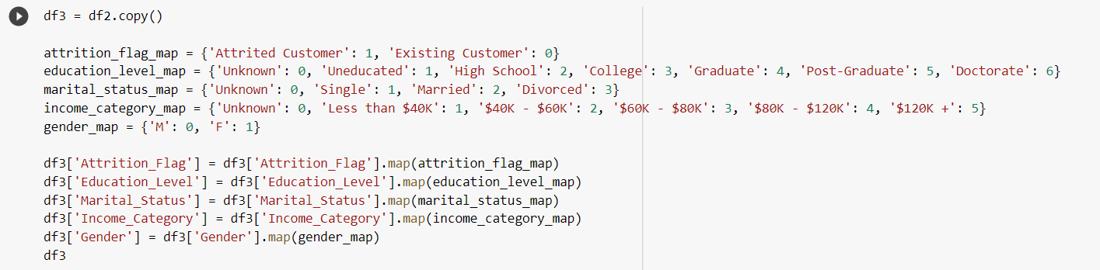
Appendix 1: Mapping categorical variables to numeric.

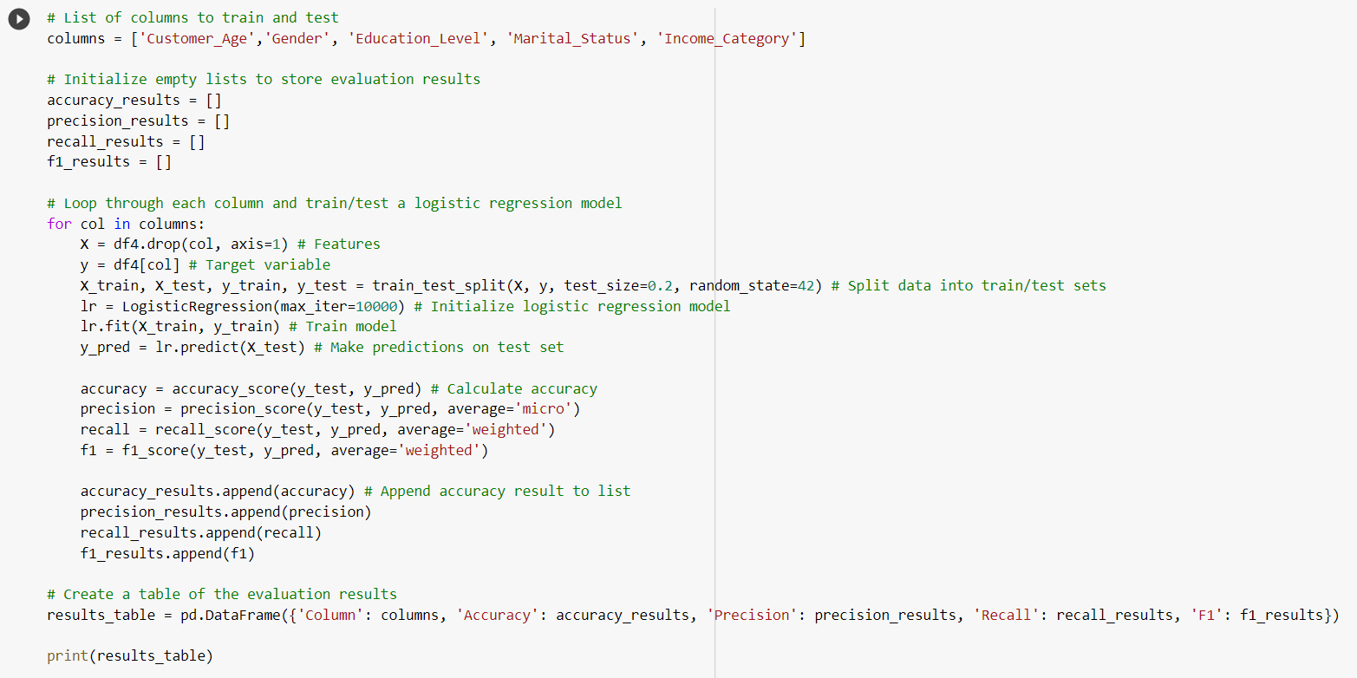
Appendix 2: Testing the Logistics regression model.

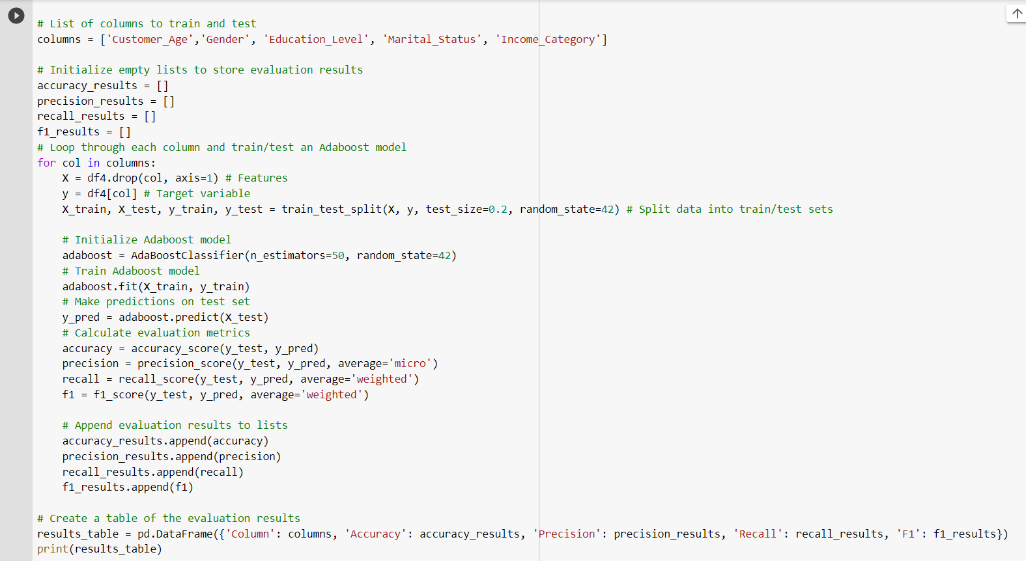
Appendix 3: Testing the Adaboost with Decision tree model.

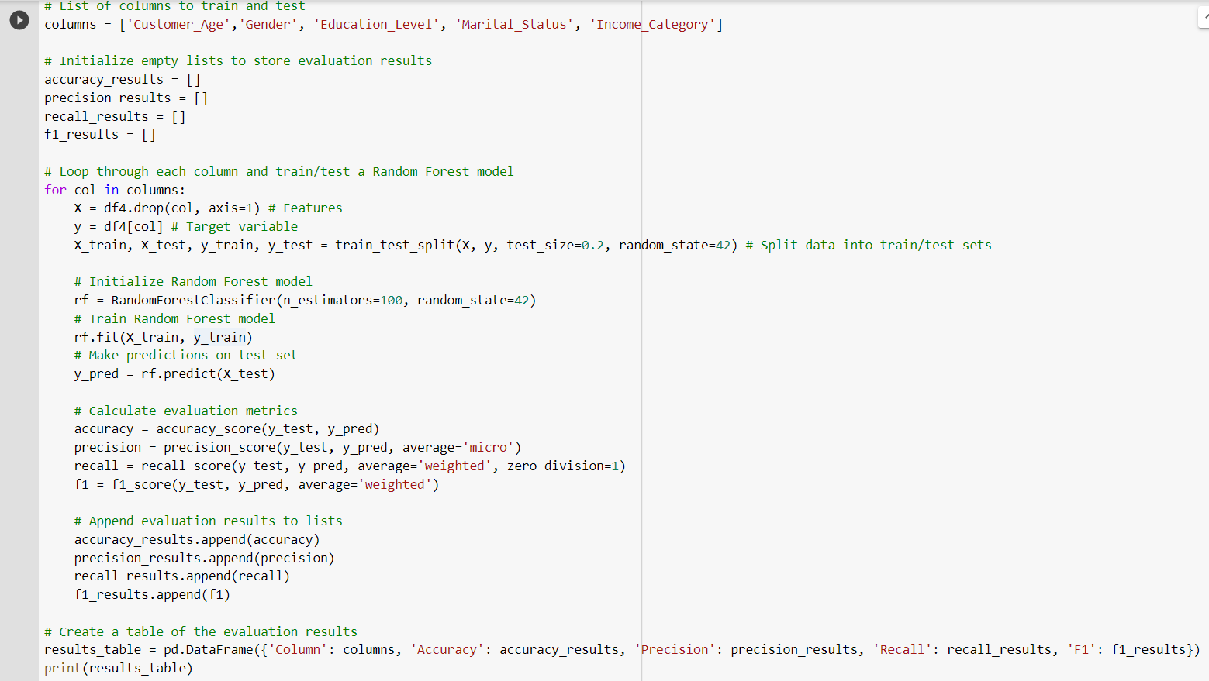
Appendix 4: Testing the Random Forest model.

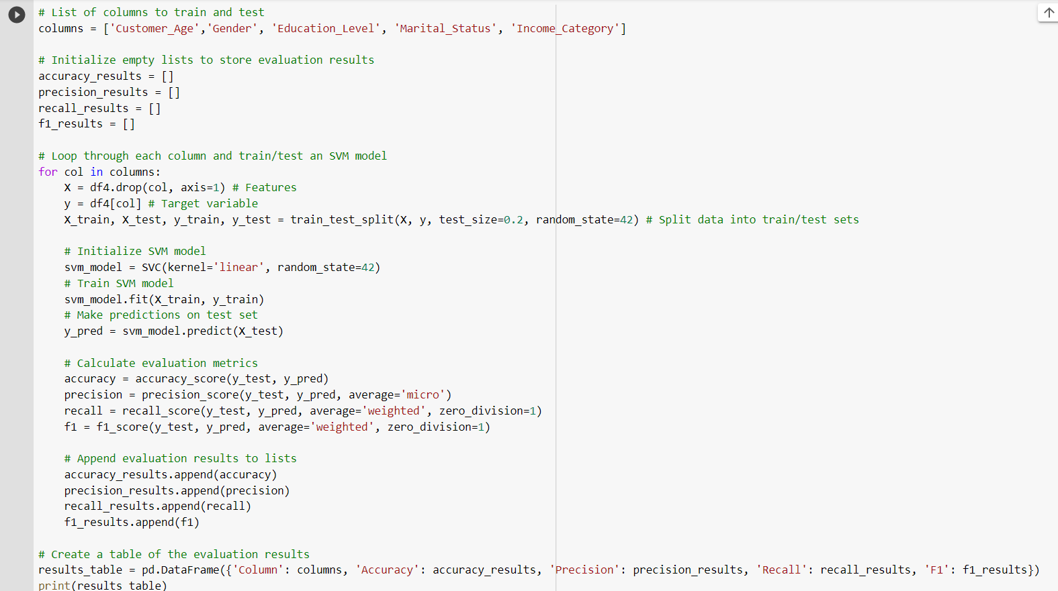
Appendix 5: Testing the SVM model.

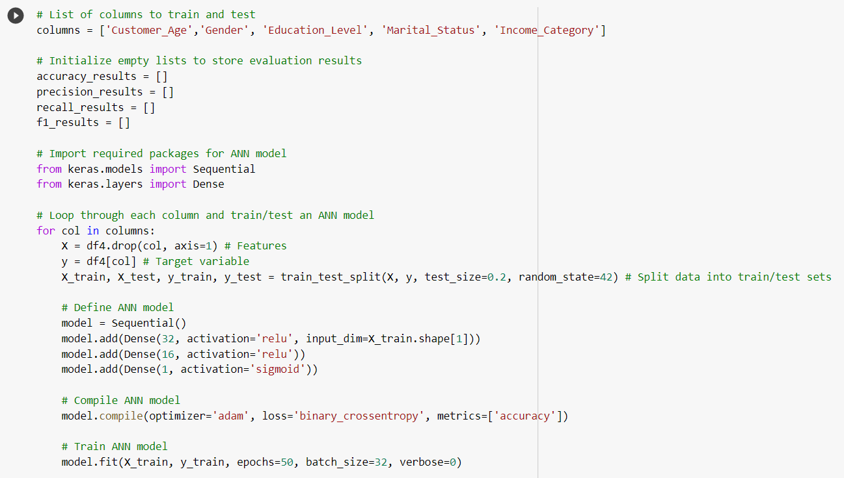
Appendix 6: Testing the ANN model.

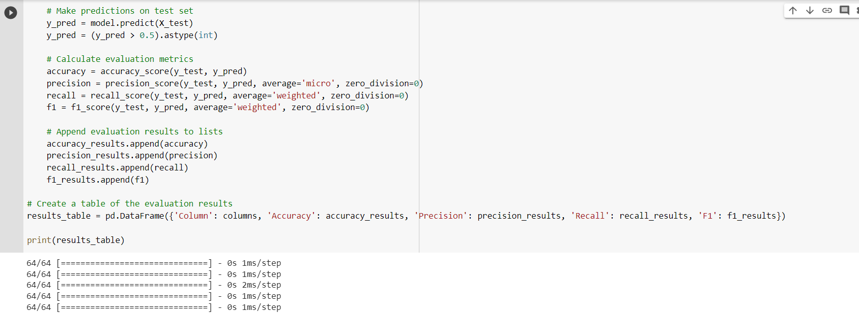
Appendix 7: Testing the ANN model.

Appendix 8: Feature Selection.



Appendix 9: Gantt Chart.
